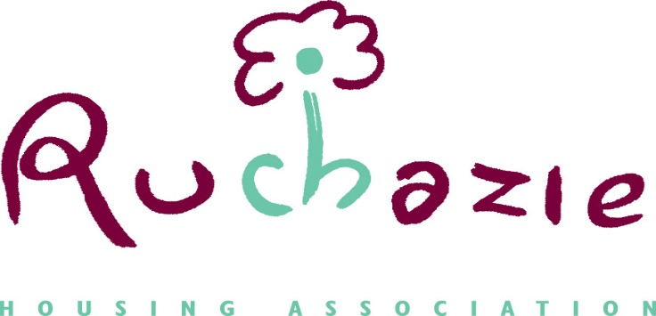

ANNUAL ASSURANCE STATEMENT
The Management Committee confirms that Ruchazie Housing Association is compliant with the Regulatory Standards of Governance and Financial Management and the requirements of Chapter Three of the Regulatory Framework.
To gain this assurance, we have reviewed and assessed a comprehensive bank of evidence that includes reports, policies, advice, assessments and information. Compliance is reported throughout the year as part of the Management Committee’s commitment to ensuring high governance standards.
We have specifically considered the available evidence to confirm compliance with our obligations in respect of tenant and resident safety. We are assured that Ruchazie Housing Association meets its safety obligations to tenants in respect of gas, water, fire, asbestos and damp and mould. We are aware that renewal of a small number [14] of EICR certificates is overdue: we understand the reasons and are assured that there is active engagement with tenants and contractors to ensure that full compliance is achieved by 31 March 2024. We are assured, based on the comprehensive bank of evidence which we have reviewed, that there are no threats to the safety or interests of tenants and customers.
We continue to monitor and manage the impact of the challenges associated with the current economic environment on our tenants and our business and maintain our assurance that the financial viability of the Association is not at risk.
We are assured that we are implementing appropriate systems to support the collection of equalities data, which we intend to take account of in our decision-making, planning and delivering services and we are considering how Ruchazie can adopt a human rights approach to our work.
We recognise that we are required to notify the Scottish Housing Regulator of any changes in our compliance during the course of the year and are assured that we have effective arrangements in place to enable us to do so.
This statement is available on our website at www.ruchazieha.co.uk
As Chair, I was authorised by the Management Committee at a meeting held on 26th October 2023 to sign and submit this Assurance Statement to the Scottish Housing Regulator.
Michelle Caldwell

Chairperson

