

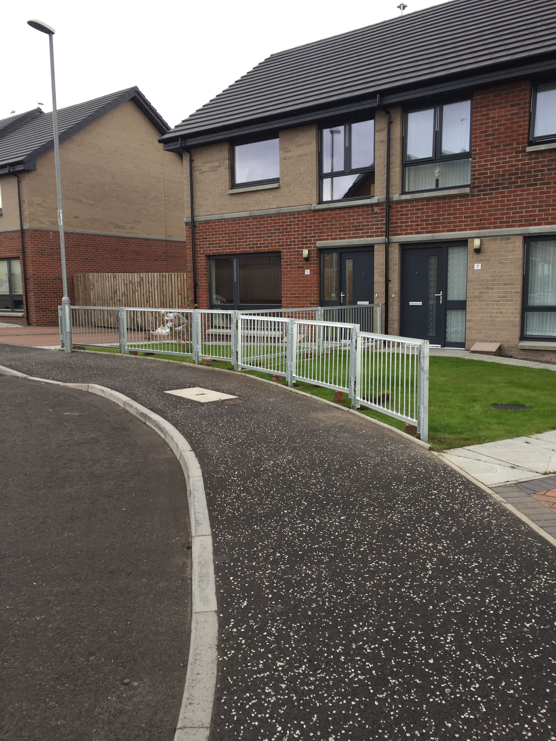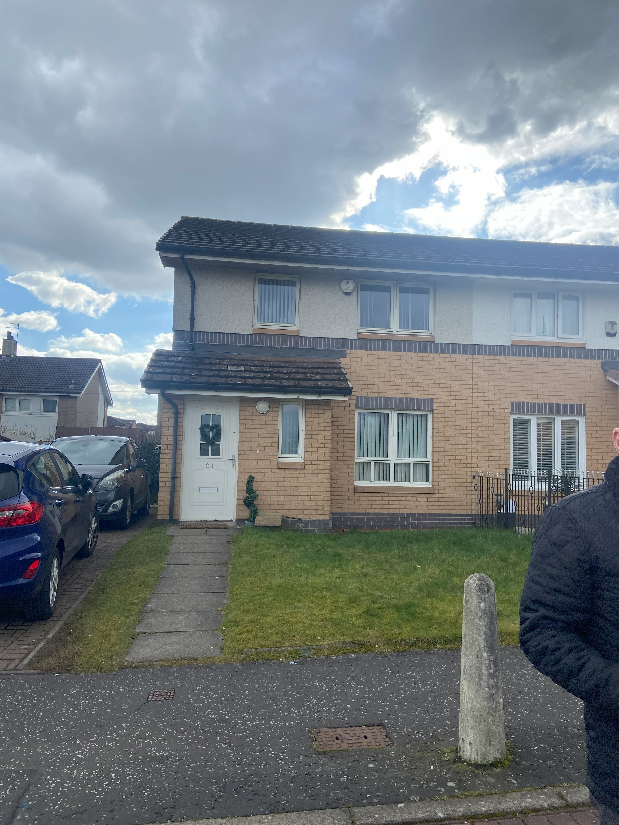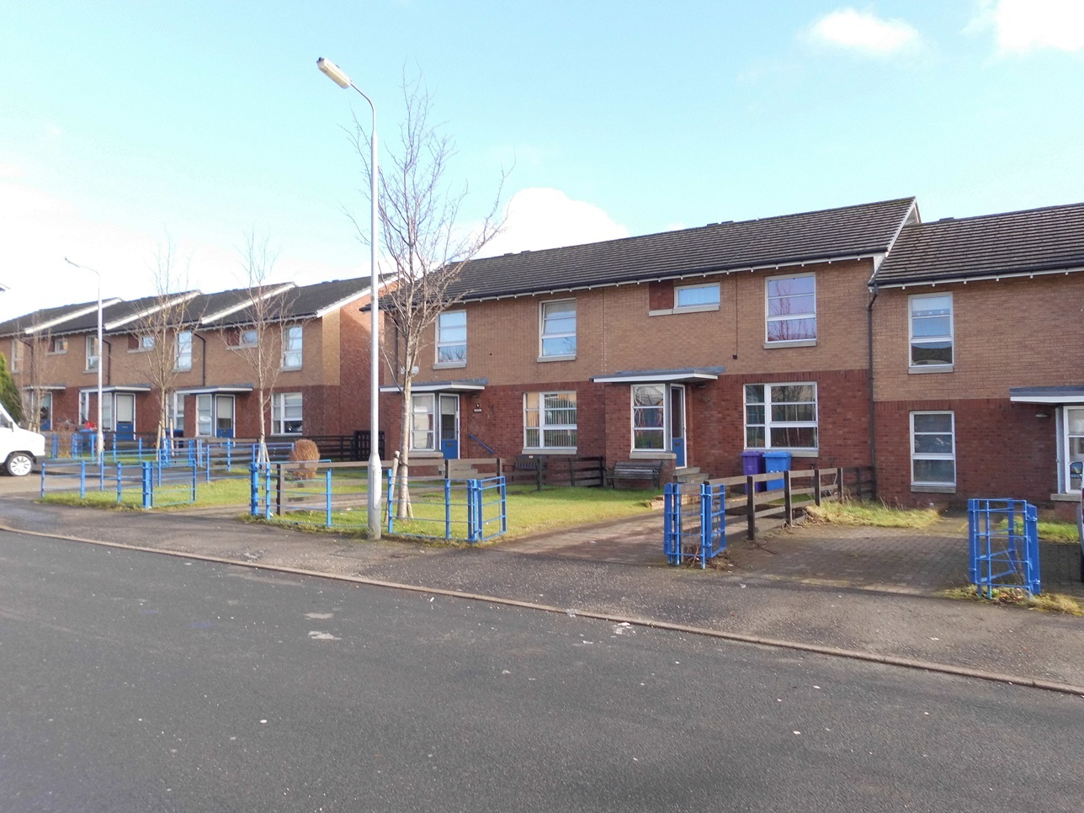

**Business Plan**

**2025- 2030**

**Contents**

1. **Introduction**
2. **About Us**
3. **Operating Environment**
4. **Risk management**
5. **Priorities**
6. **Resources**
7. **Section 1 Introduction**

This Business Plan sets our ambitions and priorities for the next 5 years. In such a fast moving changing environment it is difficult to predict the future and therefore making solid plans can be challenging. Insights from customers, committee members, staff and stakeholders have helped to create this plan.

The plan provides a framework for the implementation of our strategic objectives during the period of the plan and is supported by a delivery plan and financial plans to demonstrate how this plan will be delivered.

Whilst it is important to set clear ambitions and hold these steady, we need to give ourselves sufficient flexibility to be able to adapt to how we deliver on these ambitions, therefore this business plan is designed to support us through any further changes in our operating environment.

**Purpose of the Business Plan**

We produce a Business Plan for a number of reasons. It is primarily an internal document, serving several functions:

* Helping us to understand the opportunities and threats inherent in our operating environment as well as our own internal strengths and weaknesses;
* Clarifying and communicating our strategic objectives and priorities and setting out the key actions we will take to achieve these objectives;
* Demonstrating that we have the resources necessary to carry out these actions and helping us to identify and mitigate any risks we face in delivering these actions;
* Providing a strategic overview for our other strategies and plans; and
* Providing a framework with which we can monitor our progress and measure our success.

**Informing our Plan**

In developing this business plan, we have taken account of

* Business Planning guidance published by the Scottish Housing Regulator in June 2024

Our most recent tenant satisfaction survey ( June 2023)

Our performance against the Scottish Social Housing Charter

Our existing commitments to tenants , employees and others

Our updated financial projections ( 5years and 30 years)

Recent changes in the external environment

* Internal planning workshops, discussions and surveys (both staff and committee)
* Review of the published plans of our key stakeholders;
* Survey questionnaires with several local stakeholders;
* Tenants Focus Group
* Staff Focus Group

This Business Plan will be:

* Comprehensively updated every 5 years
* Reviewed Annually

This plan will be reviewed annually and presented to the Management Committee for final approval by March of each year, for the following financial year. Revisions may be made due to changes in the operating environment or as a result of any changes to strategy agreed by Management Committee.

* A working document reviewed regularly

For this plan to be of productive use, in addition to the above, it will also be reviewed periodically by the Director and presented to the Management Committee for consideration and approval to ensure they are alerted to any changes (either internal or external) which could affect this plan’s efficacy.

* Used as a Tool for Benchmark Analysis

Reports on both operational and financial performance will be presented to Committee on a quarterly basis.

Information concerning activities and projects aligning with and achieving strategic objectives will be routinely presented to the governing body at their monthly meetings. Any agreed action plans will be implemented, monitored, evaluated and reviewed with regular reporting on progress and achievement of key

goals.

**Section 2: About Us**

Ruchazie Housing Association (RHA) is a high-performing, community-controlled housing association operating in Glasgow. We currently own 226 homes, have an annual turnover of around £1.4m, and employ 5 staff.

We are a small, community-based housing association operating in the north-east of Glasgow. Established in 1993 to acquire and improve former council homes, we operate in what is known as the “Low End” of Ruchazie.

Having completed our first improvement programme in 1997, we have continued to work hard to transform the local area and build new homes. To date, we have completed the development and improvement of 231 properties, mainly new build, of which 226 are let to social housing tenants; one is our office; one is a commercial unit currently let as a local shop; and three are owner-occupied to which we provide factoring services. In recent years we have acquired a property through Glasgow City Council Acquisition funding and now own 226 properties.

**Our Structure**

As a registered social landlord (RSL), we are regulated by the Scottish Housing Regulator to ensure we deliver good performance for our tenants and fulfill our legal and regulatory duties. We are also a registered charity, regulated by the Office of the Scottish Charity Regulator to ensure we deliver on our charitable purposes and deliver public benefit.

Our management committee sets our strategic direction, oversees how we deliver and resource our business strategy, and ensures high standards in our operational performance. We currently have 10 management committee members; all of whom are volunteers. Currently we have 2 tenant members, 2 residents from our area of operation, and 6 members who have the required skills and knowledge in providing strategic and operational direction to the organisation. We have a small staff team of 5, led by a Director with over 30 years’ experience in managing a housing service with additional governance experience at management and committee levels. Having tenant committee members is key to our decision making process and we remain keen to recruit tenant members to our committee, however we recognise that this is challenging and we continue to seek alternative

ways to engage with tenants for this purpose.

**Our Track Record**

We operate in one of the most deprived areas in Glasgow; an area that has consistently appeared in the top 5% of the Social Index of Multiple Deprivation since its introduction in 2004. Nonetheless, the successful regeneration of the area, and the drive and ambition of our tenants and committee members, have played a significant role in improving our neighbourhood and making it an attractive place for our tenants and others to live. Tenant satisfaction with our homes and services is high – generally well over 90% – and turnover of tenancies is low. We have a healthy waiting list for our properties recognising that people want to live in our area of operation.

In previous years and particularly during the pandemic period we successfully secured funding to support our tenants through these challenging periods, as well as funding to support the establishment of The Ruchazie Pantry, a successful community project working towards eradicating food poverty as well as providing other wrap round services for the community.

Part of our success has been our long-standing commitment to working with others. For example, we previously partnered with Cube Housing Association to build homes and with Thenue Housing Association to commission development services. We are hopeful and in the early stages of securing a site at St Philips Church to develop 34 homes for social rent and continue to work with Glasgow City Council on development funding opportunities.

We recognise that playing a major role in new build development will likely be small scale as suggested above so have therefore adapted our strategy to focus on maintaining and improving our services to our tenants and the local community and this can be evidenced in our most recent Tenant Satisfaction Survey.

According to a data analysis report by Scottish Housing Networks (July 2024) our rents remain affordable, compare well with peer RSL’s and remain below the local housing allowance rate.

**Our People**

Our staff and committee members have demonstrated tremendous skill, resilience and focus over the past few years as we have worked together to strengthen our governance while maintaining high levels of service performance. This has only been achieved because of our unwavering commitment to the local community and our determination to continue to build a strong, sustainable, community-controlled housing association.

**Scale & Location**

We are one of the smallest RSLs in Scotland and we recognise this as a strength. It means that we know our customers well, understanding their needs and aspirations at an individual level, and are therefore able to offer a very personal service to our tenants. Given that we are located in the heart of our community also means that much of our interaction with our tenants is face to face which also helps to foster a more personal relationship. 91% of our tenants agree that we provide a good service in the area we operate.

**Stock**

We own and manage 226 properties in our area of operation with a good mix of house types and provide 6 purpose built ambulant wheelchair homes.

|  |  |
| --- | --- |
| Property Type | Number of properties |
| Wheelchair/Ambulant Homes | 6 |
| Tenement Flats | 69 |
| Terraced Houses | 90 |
| Own door flats | 48 |
| Semi detached Houses | 13 |

**Quality of our homes**

All our homes meet the Scottish Housing Quality Standard (SHQS). There are still challenges for all social landlords delivering the Net Zero Agenda introduced by the Scottish Government (previously EESSH), and we continue to work in the sector to ensure that we are on track to meet any legislative requirements. Over 90% of our homes are built new since 2000 and as such they continue to meet the current profile of housing demand (in terms of house size and type). Again, we are not complacent and recognise that the needs of our current tenants will change as they get older.

**High levels of demand and low turnover**

Many people want to live in this area and once here, they want to stay. We have a waiting list of around 145 households, have very high levels of tenancy sustainment and typically re-let fewer than 6 properties each year. Although we see this as a strength (providing further evidence of our good reputation and high level of tenant satisfaction), we appreciate that for those people waiting for a home, their perspective on this situation will be quite different.

**Section 3: Operating Environment**

In developing this business plan, we assessed our operating environment to ensure we remain responsive to the needs of our tenants, our community and the wider sector. We have considered:

* The current and future issues relating to our external operating environment and implications;
* The impact of the rising costs in households and our business;
* Our strengths and weaknesses and how we can build on our strengths and deal with areas for improvement; and
* The risks we café and how best to address these in terms of being able to avoid, mitigate or manage each risk

We do this to ensure we remain aligned to the changing environment; to manage threats and take advantage of opportunities that further our strategic objectives. We recognise that our operating environment is constantly changing and we continue to face and any changes may impact out services in the coming years and beyond.

The Scottish Government has produced ‘Housing to 2040’, its vision for housing in Scotland to 2040 and it’s route map to get there. The challenges in achieving its aims are relevant to Ruchazie and our community. Our Business plan recognises these challenges. We will continue to participate fully in discussions and forums about the issues facing the association.

The key challenges include

* Providing more affordable housing and reduce running costs;
* Reducing homelessness;
* Addressing the needs of an ageing population where life expectancy is becoming higher;
* Responding to the growing number of households and people who leave alone; and
* Mitigating against climate change and reducing carbon footprint.

**Our SWOT analysis (Strengths, weaknesses, Opportunities and Threats)**

In undertaking this analysis we know that there are specific areas which are challenges for many community based associations and for Ruchazie we will continue to make progress by

* Maximising tenant engagement –in recent years we have increasingly found it difficult to systematically engage with our tenants and suspect that this is largely due to the high tenant satisfaction levels experienced by tenants. 99% of our tenants are satisfied with the opportunities given to participate in our decision making process. Nonetheless, as a community-controlled housing association we are keen to see our tenants actively and genuinely participate in shaping the organisation and our services*.*
* Strengthening and sustaining good governance – Whilst we have undoubtedly made significant progress in strengthening our governance, we know there are some areas which will require our ongoing attention. These include steps to build the capacity and sustainability of our management committee (a challenge for many RSLs), enhance our assurance reporting process, continue scrutiny of our risk environment andcontinue collecting as much information as we can demonstrate an equality and human rights focus on all of our work.
* As an RSL with a staff team of only five, we have limited capacity to take on additional activities and limited capability if new skills are required. Nonetheless, with the ever-increasing demands on RSLs, the pressure to keep costs down and rents affordable, as well as our own ambitions to increase our impact, we cannot afford to stand still. All of this requires us to be focused, creative and collaborative.
* As a housing association with only 226 homes and generally no more than 6 properties available for re-let each year, we have very few opportunities to meet the current and future demand for housing. We have a waiting list of approximately 145 households which equates to around 25 households waiting for each property available for re-let each year. We also operate within a city which is experiencing increasing housing demand from an aging population with increasingly complex health and social care needs. We are hopeful we will be able to develop in the near future a small development of 34 homes to support the housing strategy locally and nationally.
* keeping in touch with sector bodies remains a priority. We can use these opportunities to connect with old and new partners, spot opportunities for new collaborative relationships, learn from others and raise our profile.

|  |  |
| --- | --- |
| **Strengths**  Size and agility  Ability to respond quickly – less bureaucracy  Well maintained stock and open spaces  Service locally based and accessible  High levels of tenant satisfaction  Strong diverse committee  Sound financial management  Strong Governance  Qualified and competent staff  High demand of stock/area  Robust treasury management practices  Good relationship with all tenants  Listening organisation  Charity Status  Affordable rents | **Weaknesses**  Size  Limited growth opportunities  Ability to influence local /national policies  Financial capacity/turnover  Attracting local/tenant committee members  Limited tenant participation engagement  Resource capacity  Limited opportunities for staff promotion  Succession planning – our size may not attract potential committee members, our performance means that tenants see no need to be involved |
| **Opportunities**  Can demonstrate RHA is attractive to investment  Good track record to attract additional funding  To make improvements  To make social impact through partnership working  Attract new board members with appropriate interest  On line improvements and digital inclusion  St Phillips development | **Threats**  Unknown costs- Net Zero Agenda  Making wrong financial assumptions  Compliance requirements increasing (Tenant Safety)  Funding opportunities eroding  Political uncertainty  Increasing costs (staff)  Mission creep- activities beyond our aims  Development requirements  Tenant apathy |

**PESTLE (Political, Economic, Social, Technological, Legal, Environmental)**

|  |  |  |
| --- | --- | --- |
| Political /Legal | Regulatory bodies and processes  Government policies  Funding/grants/initiatives  Current and pending legislation | Scot Govt target of new homes not being met.  Scottish Housing Net Zero Standards ( SHNZS)  Procurement Regulations  Data protection regulations  Scottish and UK Govt relationships  Housing Crisis  Scottish budget priorities and savings  Impact of Scot Govt Budget on local councils ability to provide adequate funding for development |
| Economic /Environment | Trends in the economy  Budget forecasts  Cost Improvement and savings plans  Geography/location  Waste disposal laws  People’s attitude to the environment | Inflation  Increase in costs  Wage inflation/NI increases  Interest rates  Impact on cost of living  Reliance on foodbank/pantries  Rent affordability agenda  Funding challenges for development, net zero .  Staff expectations on work environments /hybrid working |
| Social | Demographics, both workforce and population  Surveys/Service User Experience  Media views  Equality Impact Considerations  Ethical issues | Operating in one of the most disadvantaged SIMD’s area.  Costs for households  Increase in need for financial assistance – in work poverty  Child poverty  Changing/ Ageing population  Future demand  Customer expectations  Homelessness  Isolation and Mental Health Issues |
| Technological | Competing technological development  Research funding  Replacement technology solutions | Home/mobile working for staff  ICT costs  Innovation in energy efficiency  Mobile technology  Cyber security  Developing skills to keep pace with technology and changes  Modern workplace strategy |

**Section 4 : Risk**

Effective risk management is a core ingredient in any successful business. At a time when resources are limited, it is especially important to reduce the number of unwanted surprises. We understand the importance and value of managing risk and see our risk management policy and framework as an essential element of good governance, improving our decision-making and enhancing our outcomes and accountability.

**Approach**

We have adopted a comprehensive approach to risk management to ensure that we:

* are more flexible and responsive to new internal and external demands;
* are able to make informed decisions;
* can provide assurance to our Management Committee;
* reduce incidents and control failures; and
* are able to achieve our key targets and priorities.

**Risk Management Framework**

Our framework includes a process in which risks are identified, assessed, controlled, monitored and reviewed. The framework is designed to:

* integrate risk management into our culture;
* raise awareness of the need for risk management;
* encourage a positive approach to risk management;
* support improved decision-making, innovation and performance through a good understanding of risks and their likely impact; and
* manage risk in accordance with good practice.

**Strategic Risk Themes**

We have identified our top 4 key strategic risk themes as:

1. Governance
2. Financial sustainability
3. Recruitment and retention of key people
4. Safety and security

**Risk Register**

We maintain a detailed and up to date register of all risks, where we set out their causes and potential impact. The controls we have in place together with a scoring system helps both staff and committee to understand our risks and we use this proactively to identify, assess, monitor and review the risks to RHA. We also continue to ensure we take account of the most recent Regulatory Standards of Governance and Financial Management..

**Audit & Risk Sub-Committee**

Our Management Committee is responsible for overseeing risk management in our organisation. It is assisted by our Audit & Risk Sub-Committee, charged with monitoring the management of high-level risks, reviewing the risk appetite, ensuring proper controls are in place and annually reviewing our approach to risk management. In addition our sub-committee oversees our annual assurance statement and process and our programme of internal and external audits.

**Section 5: Strategy**

Our business strategy provides an over-arching framework for our work. It helps us to steer our course, maintain our pace and ensure that we deliver the performance standards set by our management committee. It also helps us to articulate our ambitions in a clear and consistent way.

**Remaining Independent**

A key element of our business planning process is exploring whether we can continue to best serve the interests of our current and future tenants by remaining an independent organisation, or whether it would be better , say, to merge or transfer with another housing association.

The Management Committee undertook a review of our current position, our future plans and considered our resources. The outcome of this process was that our Management Committee remains fully committed and confident that RHA can deliver our business plan ambitions and fulfil our duties and obligations to our tenants/members as an independent housing association.

Good practice suggests that it is prudent to revisit this decision at least every 5 years as part of our business planning process to check that our model remains fit for purpose and that our performance and resilience continues to improve across all areas of our business.

As part of our processes we will review this business plan every year to ensure that we continue to meet our objectives and make any necessary changes where identified.

**Vision and Values**

Our vision is:

|  |
| --- |
| ***OUR VALUES***  **R**espect   * For each other and the area in which we operate   **U**nderstanding   * The needs, wants and aspirations of our service users * Our community * Our operating environment   **C**ommunity   * Community based * Led by the community for the community   **H**elpful   * Working as a team that listens, provides answers, gives guidance * Keeping promises and honoring commitments made to others   **A**pproachable   * Working proactively * Breaking down barriers * Building relationships * Creating trust and gaining trust   **Z**ero Tolerance   * Discrimination * Abuse * Violence * Crime   **I**ntegrity   * Making sure we always do the right thing   **E**quality   * Neither consciously nor unconsciously discriminating  1. ***Community engagement –*** *embedding participation and customer engagement in our culture.* 2. ***Collaboration & partnership –*** *seeking opportunities to build relationships and work with others.* 3. ***Social inclusion –*** *tackling inequality and harnessing diversity.* 4. ***Value for money –*** *maximising and demonstrating excellent value.* |
|  |
|  |

***Ruchazie HA – ‘To provide a service that contributes to an attractive, safe, inclusive community where people want to live’***

This encapsulates the importance we give to Ruchazie as a community providing safe space and environment for everyone, where people live and want to live.

**Strategic Direction**

Like any organisation, we have gone through many different phases in our 30+ years’ journey, where each phase is influenced by various internal and external factors.

We continue to be acutely aware of the challenges faced every day in our communities, no more so in the current economic climate, and remain committed to serving our community to the best of our ability.

We recognise that the previous five years have presented great challenges for an organisation the size of Ruchazie, however we have dealt with these challenges effectively and remain committed to strengthen the organisation with a strong focus on performance, resilience, engagement and collaboration. We will apply our renewed sense of purpose, energy and professionalism to drive this through. We see these next 5 years as a phase of ‘sustainment and continuous improvement’.

**Strategic Objectives, priorities and desired outcomes**

We have reviewed our strategic objectives to ensure that we stay focused on working towards our vision over the next 5 years. All our activities will be aligned to delivering these specific objectives with agreed outcomes and targets to help us measure our performance. They are to:

1. Continue as a key community anchor and deliver high quality services that protects and puts our customers first
2. Provide high quality affordable homes that are affordable in a well-managed safe and attractive community where people want to live.
3. Manage our financial resources to protect our tenants’ interests with sound governance, effective risk and financial management.
4. Support our people to deliver excellent services to our customers
5. Be an effective and active partner in supporting and sustaining our community

**Desired Outcomes**

|  |  |  |  |  |  |
| --- | --- | --- | --- | --- | --- |
| *Strategic objective* | 1. *Continue as a key community anchor and deliver high quality services that protects our tenants and puts our customers first* | 1. *Provide high quality affordable homes that are affordable in a well-managed safe and attractive community where people want to live.* | 1. *Manage our financial resources to protect our tenants’ interests with sound governance, effective risk and financial management.* | 1. *Support our people to deliver excellent services to our customers* | 1. *Be an effective and active partner in supporting and sustaining our community* |
| *Desired results ( outcomes)* | *Our tenants are highly satisfied with our services and feel they get value for money.* | *Our homes meet all quality standards, are safe and in high demand and have low turnover.* | *We are financially strong, risk aware and well governed.* | *We have a strong and effective team of people who all feel well equipped, supported and motivated to carry out their role.* | *Our community is stable, and residents feel they have a good quality of life.* |
| *Priorities* | 1. *Strengthen our service* 2. *Deliver Value for Money for tenants* | 1. *Deliver our investment plans* 2. *Provide safe and secure homes* | 1. *Protect our financial position* 2. *Build capacity* | 1. *Develop our culture* 2. *Continue to support learning and development of all our people* | 1. *Promote partnership* 2. *Work effectively with partners to build community cohesion* |

|  |  |
| --- | --- |
|  |  |

**Our Priorities**

We have identified our top strategic priorities for the next 5 years, understanding that each one will contribute to more than one of our strategic objectives. We have set out how we will deliver on these priorities (see below) and how we will assess our progress (see appendix for our 5-year strategic delivery plan). These priorities will flow down into operational workplans and personal targets.

|  |  |
| --- | --- |
|  |  |
| 1. **Strengthen our service** |  |

We deliver a wide range of services which include all the usual housing functions provided by a community based, high performing housing association. We also offer other services from our partners to deliver Welfare Benefits and Energy Advice services. A partnership with The Wise Group gives us the opportunity to refer our tenants to their Relationship Mentoring Services, supporting tenant to sustain their homes, provide employment advice and support and assist with any other issues affecting their wellbeing.

We are committed to continuing to meet the standards set out in the Scottish Social Housing Charter and to address any service areas which would benefit from improvement. For example, in our most recent tenant satisfaction survey (2023), tenants reported a deterioration in the quality of their homes. This could be attributed to the delays in investment as the impact across the sector was felt with the pandemic and the cost of living crisis. These delayed programmes are well underway and tenants are beginning to see improvements in their homes and buildings.

We have a set of customer standards currently under review and are designed to complement the standards set out in the Scottish Social Housing Charter and will no doubt be informed by our new set of organisational values and our desire to offer a welcoming and inclusive environment. We will continue to ensure these standards are embedded in our processes and behaviors

As a small community-based housing association, we feel that we already know many of our tenants well. The pandemic has changed the way in which tenants communicate and we are experiencing a higher volume of email correspondence. Our 2023 tenant satisfaction survey indicated that over 98% of our tenants prefer to get in touch by telephone and over 88% prefer we keep them up to date by letter/newsletter. As a result of this and to provide a healthy work life balance for our staff our office remains closed all day on a Wednesday where tenants can contact staff by phone or email.

Being based most of the working week in the community we perhaps have more opportunities than most to meet with tenants. Nonetheless, it is important that we regularly and systematically take steps to better understand the changing needs and aspirations of our tenants. We will continue to do this through our formal and regular tenant satisfaction survey as well as any more informal and ad hoc tenant focus groups. We will also seek opportunities to update our customer profile which includes our duty to collect anonymised equalities data relating to the protected characteristics of current and prospective tenants.

Just as important is our understanding of the needs and aspirations of future tenants which will help us to ensure that our homes and services will meet their requirements. We will continue to work with Glasgow City Council as the strategic housing authority to understand the pressures on the current housing system and how RSLs as small as ours can still play a meaningful contribution to resolving the city’s housing needs.

Finally, we welcome the increased focus within the sector on tenant safety and recognise the different dimensions of this which cut across not just how well we look after our homes and the surrounding physical environment, but also how we ensure our services help our tenants to feel safe and secure in their homes. We have identified tenant safety as a key strategic risk for us and we have key measures to mitigate the associated risks.

|  |  |
| --- | --- |
|  |  |
| 1. **Delivering Value for money** |  |

Achieving value for money is a strategic priority for us and is one which cuts across all parts of our business. It is imperative that we invest our resources wisely, have a robust approach to deciding how to use our resources, maximise the return on our investments, understand the full cost of delivering services and safeguard the financial sustainability of the organisation.

Value for money is a way of assessing whether the benefits we offer outweigh our costs.Our priority is to ensure that the Association delivers excellent services, is financially sound and remains a well-managed organisation both now and in the future

It can be a challenge for smaller associations to achieve maximum output for minimal cost in every situation. Despite our size and the challenges we face we believe that our tenants are satisfied with our service delivery and performance.

We will proactively ensure that we utilise benchmarking information to assess and evaluate our services and costs.

Just over 82% of tenants say that rent and services provided by RHA are very good or fairly good. We know many of our tenants are in low paid jobs and we aim to ensure that our rents compare favourable to other social landlords and continue to be affordable for our tenants regardless of their income streams.

We are members of Scotland Excel and this affords us access to many procured contracts which offer value for money to our tenants and demonstrates we are following procurement legislation.

We will continue to seek out and attract grants and financial support for our tenants and enhance our partnerships.

We will continue to use feedback from our tenants to help us understand where value for money may be at risk. In our last comprehensive tenant satisfaction survey tenants said their top 3 priorities were

* A good repairs service
* Affordable rents
* Improvements to their homes

A reduction in satisfaction in our repairs service means we will focus on making improvements to our repairs service which will demonstrate our commitment to service delivery and value for money.

|  |  |
| --- | --- |
| **3. Deliver our investment plans** |  |

Improving homes is a key function of our business. As previously mentioned tenants have spoken about improvements for their homes as one of their main priorities.

To inform our plans we will undertake a planned 3 year cycle stock condition survey and review our life cycle costs. We continue to use the HUB Asset Management Tool to record and review our investment works, providing us with accurate stock condition information which allows us to sharpen our investment programmes and associated budgets.

Our stock is entering a phase where they require some major component replacement. Following a stalled period due to the pandemic and rising costs, we have restarted the kitchen replacement programme. Our investment programme outlines the component replacement requirements, cyclical and planned maintenance programmes as well as other works to improve our stock including the replacement of wooden soffits to a more appropriate and sustainable material across Phases 2 and 3 of our stock.

*We will ensure that all our properties meet the Scottish Housing Quality Standard (SHQS) and Energy Efficiency Standards for Social Housing (EESSH) where possible.*

*We will monitor Scottish Government progress in finalising its Social Housing Net Zero Standard (SHNZS) and will prepare a position Statement on what we know about standards, costs, technologies, funding etc, as the first step towards a future plan when the SHNZS proposals have been turned into firm requirements. Should extreme difficulties occur, there would be other options available to explore. These include increased borrowing, changes to planned maintenance programmes, and seeking Scottish Government funding towards net zero costs. If Scottish Government does not provide such funding, it is potentially threatening the viability of many social landlords and making an already difficult set of economic and other pressures much harder to manage.*

Improving the sustainability of our homes is also dependent on our ability to adapt properties to suit the changing needs of our tenants. As we continue to receive applications for adaptations to our homes we will take care to ensure that we use our budget allocation effectively and that any adaptation does not hinder the future allocation of the property.

Whilst we appreciate there is limited funding and limited suitable land available, we continue to explore and move towards the development of 34 new homes. We are keen to explore all opportunities to increase the number of our homes, offer a wider choice of house type, and develop the remaining gap sites in the local area. As with all our previous housebuilding programmes, we would expect to deliver any new homes in partnership with others.

**4. Provide safe and secure homes**

Tenant safety is a priority issue and strategic risk for us. As a landlord it is vital that we take the necessary steps to ensure compliance in all areas of tenant safety. We do this by maintaining clean and up to date records of all safety visits to our properties including gas safety checks and electrical installation checks. As subscribers to the EVH Landlord Safety Manual this affords us regular audits across tenant health and safety requirements and provides advice and support when required.

**5. Protect our financial position**

In the current economic climate costs are still uncertain and these pressures are on households and business alike. It is more important than ever that we closely monitor and manage our financial position. We expect the financial pressures on our rents to remain a key focus for some time, however we must ensure that we safeguard our viability and resilience.

We will continue to maintain financial discipline through rigorous financial controls, systems, accurate financial records and reporting financial performance. We will continue to strengthen our assurance and reporting systems to ensure effective monitoring of our financial position. We will commission regular audits and external compliance checks to ensure accurate reporting. We will also continue to benchmark our financial and operational performance with other registered social landlords and use this to identify where further improvements can be made.

1. **Build capacity**

As a small organisation we recognise our capacity is limited and in this time of increasing regulation and compliance, finding ways to stretch our resources can be challenging.

We will focus on strengthening our capacity through various means. We already buy in specialist services when we need them but most consider effective ways of sharing skills. We will always look to enhance our own staff skills in the first instance but will always consider accessing skills and functions from other associations.

Effective succession planning is critical to building our capacity and we will continue to encourage tenant members onto our governing body. We are aware we only have a small pool from which to recruit members. We will continue to promote the benefits of tenants being part of our decision making and having a strong committee. We will continue to provide an effective induction programme to help new members settle into their role.

We are committed to maintaining our lean staffing structure and will continue to invest in supporting staff to develop their skills and knowledge and draw in specialist skills as we require them. RHA have been accredited IIP status and believe that well-trained, supported and motivated staff deliver the best outcomes for our customers.

1. **Develop our culture**

We are committed to providing the best service to our tenants and customers. We will nurture a committed and motivated staff team who will understand and share our purpose, values and vision and who demonstrate our organisational behaviours. We will embed these values into our recruitment process and ensure that we are able to recruit diverse talent with the right behaviours.

The results from our most recent tenant satisfaction survey tell us that 100% of our tenants are satisfied with the opportunities they have to engage with us. Nonetheless, we feel tenant engagement is an area where we can make improvements, especially since only 8% of tenants are “very” satisfied with the opportunities we offer.

We updated our tenant engagement policy in 2019, renewing our commitment to being more proactive. Since then we have launched a new service improvement panel which is externally supported by TPAS. The panel currently has 6 tenant members and has already embarked on a review of our letting standards. It is hoped that the panel will conduct one review per year, reporting its findings directly to our management committee.

We are also keen to attract input from our tenants to help inform and improve our policies and plan to establish a tenants policy review register where those tenants who indicate an interest will receive a draft copy of the policy and an invitation to feed back their comments. These will then be taken into consideration when the final policy is drafted and approved.

These more formal approaches will not prevent us from holding the occasional customer focus group to test out new ideas or to seek informal feedback on particular initiatives. We have had some recent success with tenant focus groups, and they have the advantage of being a quick and inexpensive way of getting insight into the customer perspective.

We are also keen to continue to explore the opportunities to engage with our tenants digitally. We recently introduced the “MyTenancy” app for our tenants and the take up to date has been strong. We know that many RSLs struggle to achieve high levels of tenant engagement and that this is reflected across many communities. However, we also know that some RSLs have been particularly creative in their approach, some using digital channels and some not. We are keen to learn from their experience and to test out a range of different approaches to assess what works best for Ruchazie’s residents.

|  |  |  |
| --- | --- | --- |
|  |  |  |

**8. Resources**

We are fully committed to making the best use of all our resources, people and money to ensure we remain a strong, successful and sustainable organisation.

**Financial Health**

We have reviewed our financial health, updated our 5 and 30-year financial plans and continue to maintain assurance and appropriate reporting processes***.***

In overall terms, the association is in a satisfactory financial position at the start of the plan period. At the end of March 2025, we expect to have generated a surplus for the year of around £239k with cash resources of £1.118m at March 2025. The component replacement programme planned at a cost of £227k, will see our housing properties stated at £11.6m on the Statement of Financial Position with overall business net worth at just over £3.1m.

**Financial Planning**

Both our 5 and 30-year financial plans support the aspirations of this Business Plan.

Our long-term 30-year financial plans reviewed and updated on at least an annual basis, along with 5-year plans and an annual budget, are aimed at demonstrating our ability to meet all of our financial commitments, compliance with loan covenant obligations and support delivery of our strategic objectives and delivery plans in the short, medium and longer-term. Projections include a statement of comprehensive income, a statement of financial position and a statement of cash flows. The financial projections are consistent with the requirements of the Scottish Housing Regulator under the regulatory standards of governance and financial management.

**Financial Assumptions**

The key financial assumptions throughout our financial plan are:



**Overhead Costs**

Staff and other overheads including housing property insurance form the total management cost of the association. These average at a per unit cost of £1,881 (current value) across the plan period. Our projections are based on a staffing structure of 4.4 FTE (full time equivalent) to support delivery against our strategic objectives. The association is currently tied to EVH terms and conditions and there are no plans for this to change during the next five years. The staff costs / turnover ratio averages at 16.9% across the plan and compares favorably to the sector average of 20.4% for 2023/24. The plan assumes employer pension contributions on a 2:1 basis up to a maximum contribution of 12% for each member of staff. In recognition of our size and staff structure and in order to maintain strong governance and demonstrate assurance, our financial plan includes provision for a range of external services deemed to be key to achieving and evidencing the necessary assurance.

**Component Replacement**

In delivering against our strategic objective ‘to provide high quality affordable homes’, appropriate levels of investment are required to ensure compliance with government housing standards (SHQS), energy efficiency standards (EESSH) and tenant and resident safety obligations and in doing so, protect the long-term viability of our housing stock. Our financial plan reflects years 1 to 5 of our 30-year investment programme for our properties which is based on current stock condition survey data. The plan includes provision for component replacement and planned maintenance of just under £2.079m and this is funded from cash surpluses and reserves.

**Treasury Management**

Our borrowing and investment activity is managed within the context of our Treasury Management policy and associated risk register. We have an existing loan portfolio supported by the Royal Bank of Scotland and the Nationwide Building Society. Our plans include provision for the repayment of our RBS Phase 6 loan on its maturity in July 2025 and to be replaced with a Revolving Credit Facility arrangement over a 5-year term. Our RBS Phase 4 loan, currently on a fixed interest rate, will revert to variable rate interest in year 4. Future borrowing will be determined with reference to viability assessments on prospective developments such as the St Philips site along with the needs of our investment programme. Our approach to surplus cash will continue to be to invest with approved institutions for periods determined by operational liquidity requirements.

**Financial Viability**

Across Years 1 to 5, cumulative surpluses of £1.5m are achieved with cash balances closing at just under £0.5m by Year 5. Total investment in our propertie at £1.716m and loan repayments and debt servicing at £1.186m contribute to net cash outflow of £629k and a dip in liquidity ratio. Housing properties on the Statement of Financial Position are stated at £11.1m at the end of year 5. Loan debt will decrease by £1.02m over the 5-year period and the association’s net worth is expected to increase to just under £4.7m by the end of year 5. With effect from year 1, the Royal Bank of Scotland is set to waive our interest and gearing covenant obligation. As a performance measure, the covenants are comfortably maintained throughout the 5-year period. In summary and as the association enters a more intense phase in its 30-year property investment programme, a satisfactory financial position is maintained throughout the plan period with sufficient cash resources in place and if required, access to additional funding via the RBS revolving credit facility.

|  |  |  |  |  |  |  |
| --- | --- | --- | --- | --- | --- | --- |
| **Statement of Comprehensive Income (Extract)** |  |  |  |  |  |  |
|  |  |  |  |  |  |  |
| **SOCI** | **Year 0 2024/25 £'000** | **Year 1 2025/26 £'000** | **Year 2 2026/27 £'000** | **Year 3 2027/28 £'000** | **Year 4 2028/29 £'000** | **Year 5 2029/30 £'000** |
| Turnover | 1,454 | 1,477 | 1,497 | 1,533 | 1,569 | 1,607 |
| Operating Costs | (1,167) | (1,137) | (1,160) | (1,218) | (1,244) | (1,215) |
| Operating Surplus | 287 | 340 | 338 | 315 | 325 | 392 |
| Interest Charges | (48) | (46) | (33) | (26) | (24) | (39) |
| Net Surplus | 239 | 294 | 305 | 289 | 301 | 353 |
|  |  |  |  |  |  |  |
| Gross Profit Ratio % | 19.7% | 23.0% | 22.5% | 20.5% | 20.7% | 24.4% |
| Net Profit Ratio % | 16.4% | 19.9% | 20.3% | 18.9% | 19.2% | 21.9% |
| Staff cost /Turnover % | 15.7% | 16.1% | 16.9% | 17.1% | 17.1% | 17.1% |
| Management costs / Turnover % | 30.3% | 30.0% | 30.1% | 30.7% | 29.6% | 30.3% |
| Management cost per unit £ | 1,947 | 1,959 | 1,993 | 2,084 | 2,059 | 2,156 |

Rental income is our only income source and annual rents increases are the main driver for the movement in turnover across the plan. Operating costs are reflective of inflationary increases and vary annually, depending on the planned maintenance profile. Net surpluses are generated, with gross and net profit ratios showing improvements against Year 0.

|  |  |  |  |  |  |  |
| --- | --- | --- | --- | --- | --- | --- |
| **Statement of Financial Position (Extract)** |  |  |  |  |  |  |
|  |  |  |  |  |  |  |
| **SOFA** | **Year 0 2024/25 £'000** | **Year 1 2025/26 £'000** | **Year 2 2026/27 £'000** | **Year 3 2027/28 £'000** | **Year 4 2028/29 £'000** | **Year 5 2029/30 £'000** |
| Housing Properties | 11,597 | 11,402 | 11,277 | 11,190 | 11,127 | 11,107 |
| Housing Grant | 7,782 | 7,467 | 7,151 | 6,835 | 6,519 | 6,203 |
| Cash | 1,118 | 625 | 671 | 623 | 558 | 489 |
| Loans | 1,718 | 1,070 | 981 | 890 | 796 | 699 |
| Net Worth | 3,117 | 3,411 | 3,716 | 4,005 | 4,307 | 4,660 |
|  |  |  |  |  |  |  |
| Current Ratio | 1.11 | 1.28 | 1.41 | 1.30 | 1.16 | 1.04 |
| Debt per unit £ | 7,600 | 4,735 | 4,342 | 3,937 | 3,521 | 3,091 |

|  |  |  |  |  |  |  |
| --- | --- | --- | --- | --- | --- | --- |
| **Statement of Cashflows (Extract)** |  |  |  |  |  |  |
|  |  |  |  |  |  |  |
| **CASHFLOW** | **Year 0 2024/25 £'000** | **Year 1 2025/26 £'000** | **Year 2 2026/27 £'000** | **Year 3 2027/28 £'000** | **Year 4 2028/29 £'000** | **Year 5 2029/30 £'000** |
| Net cash In /(Out) from Operating Activities | 543 | 433 | 499 | 450 | 462 | 528 |
| Net Interest Received/ (Paid) | (48) | (46) | (33) | (26) | (24) | (39) |
| Loan Repayment | (119) | (647) | (89) | (91) | (94) | (97) |
| Component Replacement | (229) | (233) | (306) | (356) | (384) | (436) |
| SHAPS Pension Deficit | 0 | 0 | (25) | (25) | (25) | (25) |
| **Net Cashflow In /(Out)** | **147** | **(494)** | **47** | **(49)** | **(64)** | **(69)** |
|  |  |  |  |  |  |  |
| Opening cash | 971 | 1,118 | 625 | 671 | 623 | 558 |
| Net Cashflow In /(Out) | 147 | (494) | 47 | (49) | (64) | (69) |
| Closing Cash | 1,118 | 625 | 671 | 623 | 558 | 489 |

Our Statement of Financial Position shows a net decrease in the carrying value of housing properties, as the value added though component replacement spend is offset by the annual depreciation charge. Cash drops in Year 1 with the repayment of the Royal Bank of Scotland Phase 6 loan balance and liquidity (current ratio) shows a decline from year 3 as cash reserves are utilised to fund more intensive component replacement programmes.

|  |  |  |  |  |  |  |
| --- | --- | --- | --- | --- | --- | --- |
| **Loan Covenants** |  |  |  |  |  |  |
|  |  |  |  |  |  |  |
| **Royal Bank of Scotland** | **Year 0 2024/25 £'000** | **Year 1 2025/26 £'000** | **Year 2 2026/27 £'000** | **Year 3 2027/28 £'000** | **Year 4 2028/29 £'000** | **Year 5 2029/30 £'000** |
| Gearing | 16% | 10% | 9% | 8% | 7% | 6% |
| Maximum < 30% | 30% | 30% | 30% | 30% | 130% | 230% |
| Interest Cover | 324% | 478% | 371% | 239% | 202% | 180% |
| Minimum > 110% | 110% | 110% | 110% | 110% | 110% | 110% |

**Stress Testing**

In order to ensure our financial planning is robust and can respond to any future uncertainties or changes, we carry out sensitivity analysis to stress test our key assumptions. The following financial sensitivities have been assessed against the base case plan:

|  |  |
| --- | --- |
| **Ref** | **Sensitivity** |
| 1 | Increase CPI Inflation to 5% in Yr 1 |
| 2 | Increase CPI Inflation to 10% in Yr 1 |
| 3 | 10% Increase to Component Rates in Yr1 |
| 4 | Maintenance rates remain elevated at CPI +2% across years 1-5 |
| 5 | Increase pension deficit payments to £50k/year |
| 6 | CPI inflation remains above 1% above BofE 2% target across yrs 2-5 with no corresponding rent increase |
| 7 | Combine 3 & 6 |
| 8 | Combine 4 & 5 |

The cost of living and economic challenges experienced in recent years, have to some extent eroded the association’s financial headroom. The stress test results demonstrate that the association has little in the way of excess capacity to readily absorb the impact of yet further extreme economic conditions. Ultimately, no lender would accept a continuing outflow of funds without remedial action being taken. An ongoing alertness to changes in economic conditions is critical as we move through the plan and in the event of significant change to our assumptions, appropriate action will be taken to ensure the association remains viable and fully compliant with lender loan documents terms.

**Our People**

Our people are our voluntary committee members and our paid staff, who together continue to demonstrate commitment to the community led ethos of our organisation. Our staffing structure is as follows:

* Director
* Senior Housing Officer
* Finance officer
* Property Services Officer
* Customer Services Assistant

We will continue to develop a strong team of talented and committed people. This will include annual committee reviews and updates of our committee training and development plan, our staff appraisal process and embed our organisational values. We will continue to encourage and support our people to network with other organisations to share learning, explore new ideas and maintain an objective perspective.

We recognise that as a small team working in an ever-changing context there will be times when we will need to supplement our capability with effective collaboration arrangements and have accordingly made appropriate provision in our financial projections. We do this to support our governance, development aspirations and financial plans.

**Our Systems**

We are committed to continuing to invest in our systems to improve our productivity, efficiency, services and communication. In our last business plan we explored new housing management systems and have recently migrated to an upgraded web based system. This system also included the opportunity to move to an integrated finance module, which can streamline our financial function.