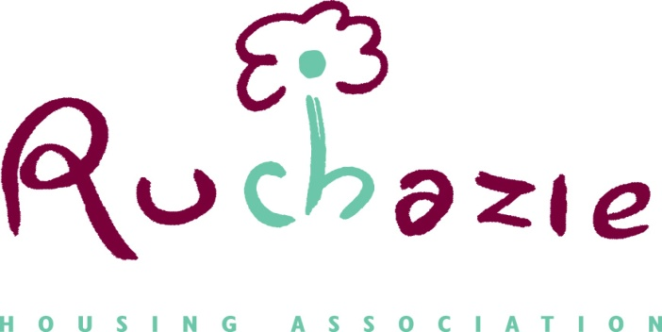

COMPLAINTS AND COMPLIMENTS POLICY

Date of Policy | March 2021
Date approved | January 2019
Date for Review | March 2024

- Introduction
Ruchazie Housing Association (RHA) strives for high standards and we are committed to listening to the views of our members, tenants, customers and other stakeholders. Feedback is essential in helping us evaluate and improve.

- Purpose
The purpose of this policy is to ensure that:
• RHA knows what our customers and stakeholders value, what they think we do well and where they think we could do better.
• Customers and external stakeholders know how to provide feedback and how a complaint will be handled.
• Complaints are dealt with consistently, fairly and sensitively within clear and reasonable timeframes.
- Individuals have a simple and effective way to comment on RHA’s work and services

- Compliments and complaints are monitored and used to improve our services and how we work.

- Compliment
A compliment is any expression of positive feedback by a customer or external stakeholder. Compliments are valuable, welcome and important. They let us know when the services we provide are good, influence development of our services and quality assurance and let our people know when they’ve done well. We welcome compliments online, in person, on the phone, by letter or email.

- Complaint
A complaint is an expression of dissatisfaction about our action or lack of action, or about the standard of service provided by or on behalf of RHA. We have adopted the Scottish Public Services Ombudsman’s Complaints Handling Procedure and copies of this are available from our website. Complaints are taken seriously and will be responded to in a timely, fair and consistent manner in line with the Scottish Public Services Ombudsman (SPSO) guidance. They enable RHA to identify when the services we provide don’t meet the standards expected by our customers or stakeholders, help us do better and influence the development of our service delivery and quality assurance.
We welcome complaints online, in person, on the phone, by letter or email. This policy relates only to complaints received by RHA from external stakeholders. Staff complaints will be dealt with in accordance with RHA’s policy on Grievances.

- Anonymous compliments and complaints
We will record and consider any compliments and complaints that are received anonymously. Our ability to take action may be limited if fuller information is needed to conduct a full and fair investigation, to make improvements or to ensure the right people receive positive feedback so we would encourage anyone wishing to give a compliment or make a complaint to let us know who they are.

- Monitoring
Compliments and complaints are important tools; feedback allows RHA to improve the services we provide. They offer useful information about how individuals see us and the work we do. Any information obtained will be considered regularly by senior staff and our Management Committee. Wherever possible, the information will be used to improve and further develop our services. Compliments or Complaints can be made as follows;
Online at RHA’s website https://www.ruchazieha.co.uk/compliments-complaints/
In person or by letter Ruchazie Housing Association
24 Avondale Street
Glasgow G33 3QS

By phone 0141 774 4433

- Review
This policy will normally be reviewed no later than 3 years from the date of approval by the Management Committee. In the event that this policy statement is not reviewed within the above timescale, the latest approved policy statement will continue to apply.

