

Condensation
Condensation is by far the most common cause of dampness in buildings, probably accounting for the majority of damp problems reported. It affects both old and new buildings, but it appears to be a significant problem where the building has been modernised.
Condensation is directly associated with mould
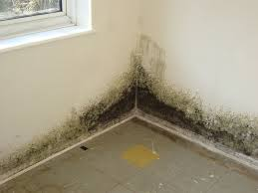
growth. It is that the occupier sees first, and it
gives an indication of the potential scale of the
problem. The mould is usually found on decorative
surfaces, especially wallpapers, where it can cause
severe and permanent spoiling. In many cases, the
mould spores (seeds) give rise to complaints
Mould on walls caused by condensation
about health, and cause the musty odour frequently
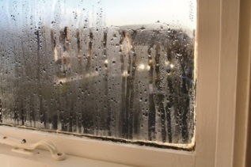
associated with a damp house.
Condensation on window
The obvious places for condensation to occur are on
cold walls, windows, and floors, but it can also occur
in roof spaces and in sub floor areas where there is a
timber suspended floor; in the latter case, it can lead
to dry rot or wet rot developing in floor timbers.

The cause
It is a fact that warm air can hold more water as vapour than cool air. Condensation is caused when moisture-laden air comes into contact with a cold surface-the air is cooled to the point where it can no longer hold its burden of water vapour. At this point, known as the dew point, water begins to drop out of the air, and is seen as condensation on surfaces. On impervious surfaces such as glass and gloss paint, beads or a film of water collect. On permeable surfaces such as wallpaper and porous plaster, the condensing water is absorbed into the material. Therefore, the problem is not always initially obvious.
Identification
Condensation is very much a seasonal problem, occurring during the colder months October to April. During the summer, the problem is seen to go away. During the winter, ventilation of the house is usually low (due to windows and doors being close, draught-proofing takes place). This allows build-up of water vapour in the house, which in some cases is sufficient to cause condensation.

This condensation becomes apparent from the following symptoms:
- Water droplets form on cold, impervious surfaces such as glass and paint
- Slightly damp wallpaper (often not noticed)
- Development of moulds, usually black mould

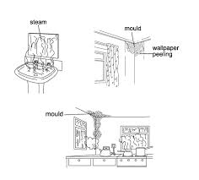
In some cases, condensation may be long term
but intermittent, forming only at certain times of
the day or night. In these cases, the only sign of
condensation may be mould growth, as the
moisture may have evaporated by the time
moisture measurements are taken.

You should also be aware that the problem can
occur well away from the site of most water
vapour production. E.g. water vapour produced
in the kitchen may diffuse through the house into
a cold bedroom where it will condense on cold
walls.

Confirmation

At staff discretion, a humiditect card can be fixed to the surface where condensation is suspected for 7 days (due to the intermittent nature of the problem). Spots of colour printed on the card will gradually bleed depending on the severity of the problem. This device will prove the presence of condensation over suspected water dampness.

Control of condensation

The control of condensation is based on two very simple primary measures, supported by a number of secondary measures.

Improve ventilation
This will sweep away the internal moisture-laden air and replace it with drier air from the outside (yes, external air is drier than internal air most of the year)

Improve heating
Coupled with ventilation, heating should be set or applied to give low level background heat. This will ensure no rapid changes to the environment, and will facilitate slight warming of wall surfaces over a period of time, thus reducing the risk of condensation.

Secondary measures
Remove excess moisture sources- e.g. paraffin heaters, indoor drying of clothes.
Insulate cold surfaces.
Prevent possible water penetration.
Use anti-mould paint

