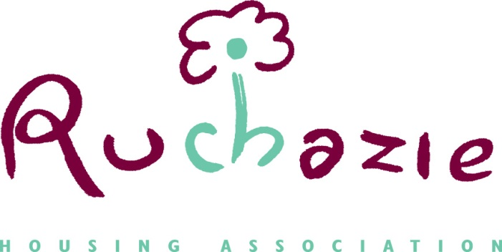

RUCHAZIE HOUSING ASSOCIATION
ESTATE MANAGEMENT POLICY

Date of Policy | January 2023
Date approved by Management Committee
Date for review

- Introduction

  - The purpose of this policy is to set out the Associations commitment to effective estate management and has been devised to reflect the outcomes and standards set by the Scottish Housing Regulator.

  - Ruchazie Housing Association recognise the importance of a comprehensive estate management service which is effective in ensuring that the area of operation is attractive, well maintained and a safe place to live in.

  - Ruchazie Housing Association are committed to providing high quality homes, maintaining a welcoming environment.

- Aims and Objectives

  - The aim of the policy is to provide a framework to deliver a first-class estate management service. We want to achieve the appropriate balance between prevention and enforcement action. We will do this by:

- Ensuring resident satisfaction by offering a welcoming, stable and vibrant environment where residents feel pride in the local area.

- Providing clear service standards and managing performance to ensure good service delivery and tenants comply with obligations as set out in the tenancy agreement;

- Ensuring estate management services are planned, adequately resourced and effectively managed

- Providing an accountable and transparent service that meets the needs of our residents and community

- Develop and maintain a partnership approach with Strathclyde Police Scotland, Glasgow City Council and other agencies;

- Provide an accountable and transparent service that meets the needs of our residents and community

  - That all residents feel confident and able to report problems and understand remedies available to address problems.

A further aim of this policy is to also pay recognition to those members of the community that take pride in their local area by carrying out an annual garden competition at our annual general meeting.

  - That this policy links with our strategic objectives.

3. Equal Opportunities

3.1 Ruchazie Housing Association is committed to equal opportunities for all sections of the community. Accordingly, no person will be discriminated against during the implementation of this policy on the grounds of sex, marital status, family circumstances, race, ethnic or national origins, disability, age, religion, political or sexual orientation.

3.2 In this context, the policy can be made available in a variety of different formats including large print, alternative languages and audiotape.

4. The Legal and Regulatory framework

4.1 The main legislative provision relating to the policy is the Housing (Scotland) Act 2001.

4.2 This policy has taken into account the requirements set out in social housing charter that became effective on 1 April 2012.

Outcome 6: Estate Management, anti-social behaviour, neighbour nuisance and tenancy disputes

Social landlords ensure that:

- Tenants and other customers find it easy to communicate with their landlord and get the information they need about their landlord, how and why it makes decisions and the services that the landlord provides.

Outcome 13: Value for Money

Social landlords manage all aspect of their business so that:

- Tenants, owners and other customers receive services that provide continually improving value for the rent and other charge that they pay.
4.3 The Ruchazie Housing Association Scottish Secure Tenancy Agreement is the contractual relationship between the Association and our tenants.

4.4 The Tenancy Agreement explains tenants’ estate management obligations. This includes the keeping of pets, garden maintenance and the removal of rubbish.

5 Estate Management Service Standards
5.1 Garden Maintenance
5.1.1 The Tenancy Agreement outlines tenants have to take responsibility for ensuring their garden is clean, tidy and not causing a nuisance.
5.1.2 Gardens are inspected on a regular basis. Every week staff carry out an estate management inspection of the area. If gardens are not maintained to a satisfactory standard, the Association will take the necessary action to address the issue.
5.1.3 Generally, when an untidy garden is identified contact is made with the tenant. This can be in any form – phone, letter or card through the door.
5.1.5 The Association operates a garden maintenance service. This is for residents who are unable to maintain their garden due to health issues and do not have family to assist. The Association will review eligibility on an annual basis.
5.1.6 To qualify to be admitted to our garden maintenance service list you must be:
- Over 65 years of age
- In receipt of high rate mobility allowance
- Have no other person resident within the property who is able to assist
5.2 Pets

5.2.1 Section 2.6 of the Tenancy Agreement states tenants have to keep any pet under proper control and ensure it does not cause a nuisance in the house or locality.

5.3 Graffiti and Vandalism
5.3.1 The Association, when identified, aims to remove offensive graffiti (e.g. sectarian, racist, obscenities etc.) within 24 hours. Any graffiti found in a close we aim to remove within 5 working days. All other types of graffiti will be passed to Glasgow City Council to remove.
5.3.2 The Association will interview residents to identify perpetrators of graffiti and vandalism. The Co-operative considers this a breach of tenancy and will actively seek to recover the costs of the repair work.

5.4 Removal of rubbish and bulk
5.4.1 Section 2.13 of the Tenancy Agreement outlines it is an obligation of the tenancy agreement to put rubbish in the appropriate bin for collection.
5.4.2 If the Association has to remove bulk rubbish, we will attempt to identify those responsible. It is our policy to recharge for the cost of this work.
5.4.3 The Association provides a comprehensive litter pick-up of the area once a week.
5.5 Stair Cleaning

5.5.1 The Associations will clean all common close stairways on a fortnightly basis. There is no additional charge for this. Tenants are responsible for the cleaning, washing and keeping the common stair tidy.

5.5.3 The Association will regularly inspect common areas and closes and take appropriate action where required.

5.6 Open spaces and common grounds

5.6.1 The Associations ground maintenance contractor will regularly cut common areas removing all grass, cut communal hedges and remove cuttings and maintain all shrub beds.

5.7 Car parks and paved areas

5.7.1 The Association will inspect on a regular basis and take appropriate action when necessary.

5.7.2 The Association will remove weed growth and moss from all hard and paved surfaces twice a year (this includes communal parking bays but does not include driveways attached to an individual property) It’ s expected that tenants take responsibility for their driveway.

5.8 Play park and games court

5.8.1 The Association will maintain the play park and games court, inspect on a regular basis and carry out repairs when required.

6 Agency & partnership working
6.1 Ruchazie Housing Association recognises the need to develop and maintain effective working with external agencies to ensure a high-quality physical environment.
  - In particular, we will liaise with the following agencies:

• Police Scotland
• Glasgow City Council (particularly, Cleansing)
• Community Safety Services (Environmental taskforce)
- Glasgow Housing Association

7 Communication
7.1 Measures are in place to collect and analyse the resident’s experience of receiving our services. This includes stair cleaning and garden maintenance services surveys.

8 Resident Participation

8.1 Effective estate management is a result of having good links with the community. Accordingly, residents will be encouraged to participate in regular walkabouts with staff.

8.2 Measures are in place to collect and analyse the individual’s experience of making a complaint.

9 Monitoring and Reporting
9.1 Ruchazie Housing Association Management Committee will receive reports that will monitor and evaluate performance.
9.2 The Property Services Officer will closely monitor the ground maintenance contractor’s performance.
10 Complaints

10.1 Any user that is dissatisfied with the service experienced should be encouraged to provide feedback. The Associations complaints procedure sets out how we manage complaints.

11 Review
11.1 This policy will be reviewed every 3 years or earlier if required.

