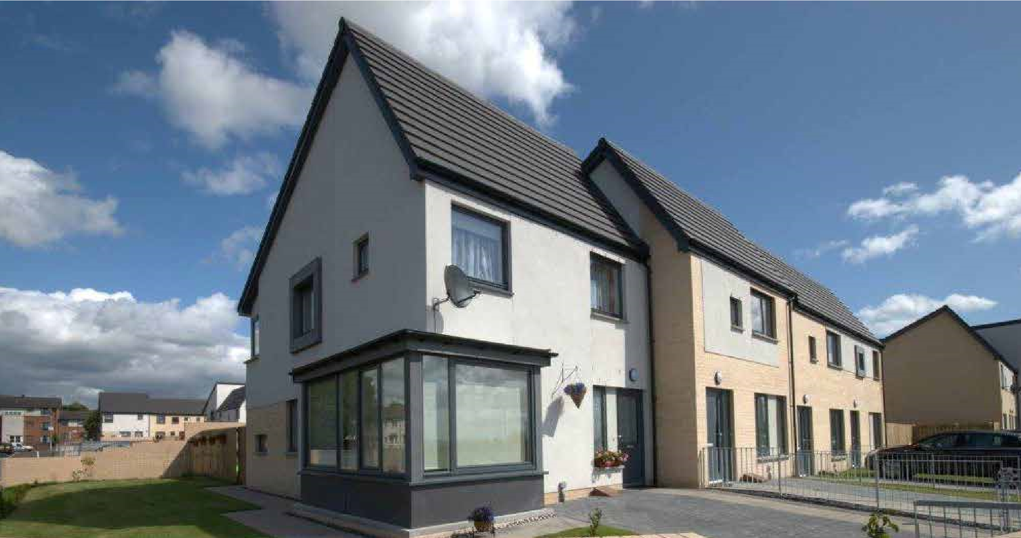
Apartment Size
House Type Required
Points Total
Housing Application Form
Ref No:
Date Received

 | PERSONAL DETAILS
Applicant |  | Joint Applicant
Full Name: |  | Full Name:
Date of Birth: |  | Date of Birth:
Address: |  | Address:
Flat Position: | Postcode: | Flat Position: | Postcode:
Tel Home: |  | Tel Home:
Tel Mobile: |  | Tel Mobile:
Email: |  | Email:
National Insurance No: |  | National Insurance No:
People to be rehoused with you
Name
Date of
Birth
dd/mm/yy
Relationship to
Applicant
Current Addres
s if
different from
Applicant
Please tick
if children
access only
How many bedrooms in our current home?

What Floor is it on?
Is anyone in the household pregnant? | Yes |  |  | No
If yes when is the baby due |  |  |  | Please provide  proof i.e. Pregnancy  Record
Access to Children
If you have access to children please give brief details below:

People in your current home who will not be rehoused with you
Name |  |  |  |  | Date of Birth  dd/mm/yy |  |  | Relationship to Applicant
 |  |  | CURRENT ADDRESS
What is your current tenure (e.g. Tenant, Owner, lodger)
Who is your current landlord:
Landlord Address:
Date of Entry:
MAIN APPLICANT: PREVIOUS ADDRESSES
Have you ever lived in a property owned by Ruchazie Housing Association: |  |  |  |  |  | YES |  |  | NO
Address: |  |  |  |  |  | Date of Entry  & Date of Leaving
Reason for Leaving:
PREVIOUS ADDRESSES:
Please provide details of your addresses for the last five years
Address |  | Landlord’s Name & Address |  | Tenant/Lodger/ Owner |  |  | Date of Entry  & Date of Leaving |  |  | Reason for Leaving

Have you ever been evicted? |  |  |  |  | YES |  | NO
If Yes, give details:
JOINT APPLICANT: PREVIOUS ADDRESSES
Have you ever lived in a property owned by Ruchazie Housing Association: |  |  |  | YES |  | NO
Address: |  |  |  | Date of Entry  & Date of Leaving
Reason for Leaving:
PREVIOUS ADDRESSES:
Please provide details of your addresses for the last five years
Address |  | Landlord’s Name & Address | Tenant/Lodger/ Owner |  | Date of Entry  & Date of Leaving |  | Reason for Leaving
Have you ever been evicted? |  |  |  |  | YES |  | NO
If Yes, give details:

HOMELESSNESS
Do you consider yourself to be homeless? |  | YES
 |  |  |  |  | NO
Have you been assessed by your local authority? |  | YES
 |  |  |  |  | NO
If yes please provide a copy of the Assessment Letter.
If yes please provide the name of your caseworker and area offi |  |  | ce:
Name of Caseworker: | Address of Area |  | Office:
Why have you become homeless?
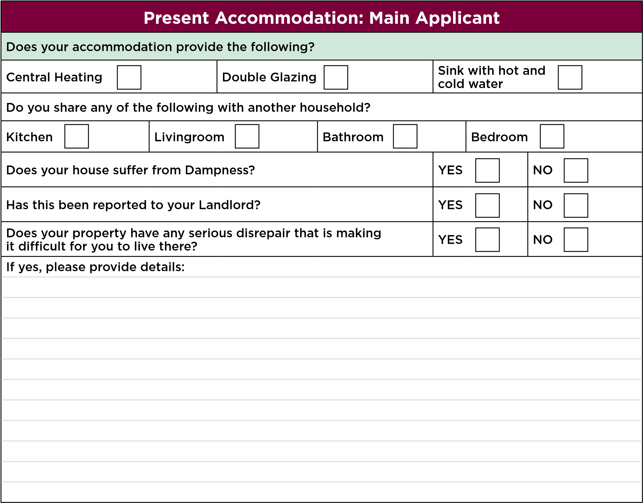
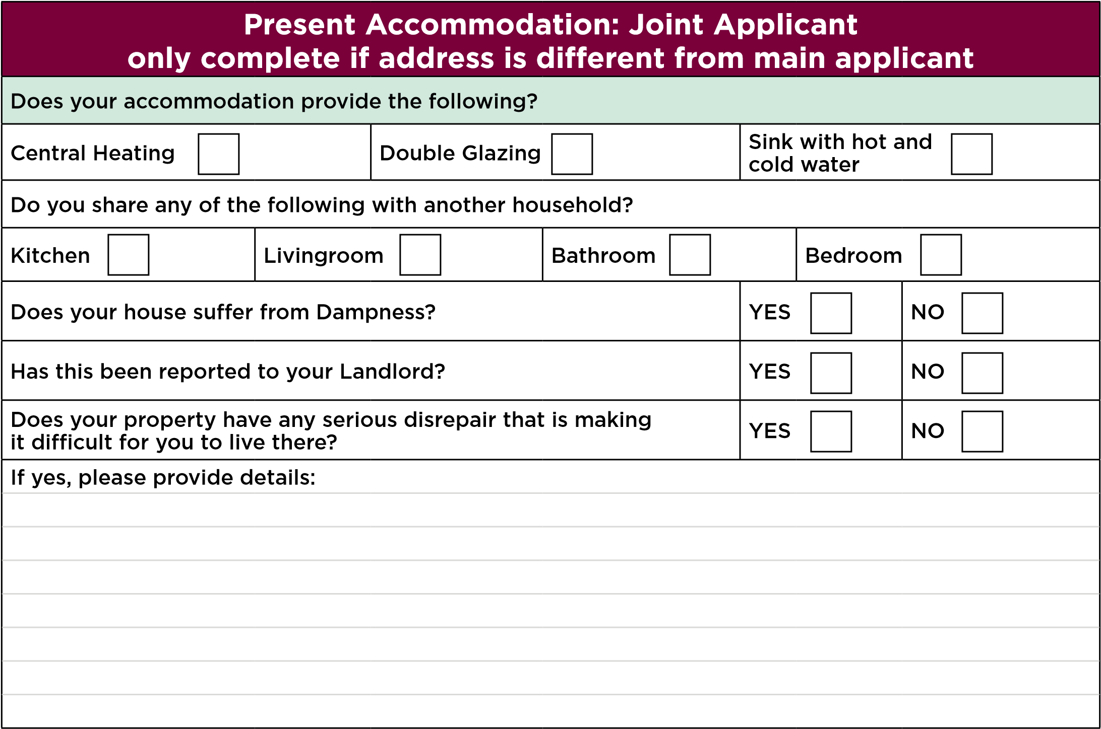
SOCIAL SUPPORT
Do you want to move to the area to give support to, or receive support from, someone who lives within the Ruchazie area? |  | YES | NO
If Yes, please provide support information:
Name:
Address:
Details of support given or received:
LOCATION NEEDS
Do you want to move to be closer to your place of employment, training, education or voluntary work? | YES |  |  | NO
If Yes, please provide details:

GENERAL INFORMATION
Arrears - Are you in arrears with your current landlord/ mortgage lender? | YES | NO
If Yes, please provide details of the repayment plan agreed to reduce and clear the arrears:
Anti-Social Behaviour - In the past 6 months has any action been taken against you, or anyone who will be rehoused with you, for anti-social behaviour? | YES | NO
If Yes, please provide details:
Criminal Convictions – Do you, or anyone who will be rehoused with you, have any criminal convictions which are not spent under the Rehabilitation of Offenders Act 1974? | YES | NO
Sex Offenders – Are you or anyone who will be rehoused with you, on the Sex Offenders Register? | YES | NO
Harassment - Are you currently being harassed at your present address, and feel you would have a better quality of life if you moved to the Ruchazie Area? | YES | NO
Relationship Breakdown – Are you applying for housing as a result of separating from your current partner? | YES | NO
Please provide information below.
Referrals – Are you being referred to Ruchazie Housing Association by a specialist body? (e.g. Social Work or other support agencies.) | YES | NO
Please provide information below.
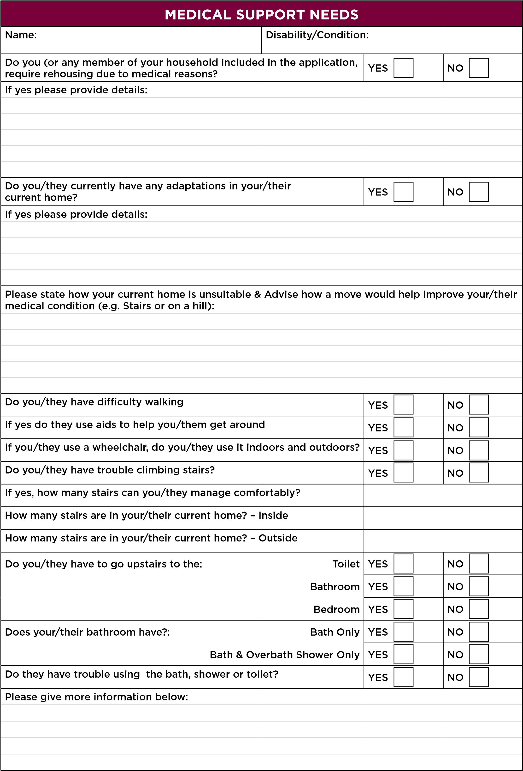

Is an extra bedroom required due to you/their medical condition: |  |  |  |  |  | YES |  |  |  |  | NO
If yes, please explain why below:
What type of heating do you have in your current accommodation?
 |  |  | Gas |  |  | Electricity |  |  |  |  | Other
Does this affect your/their medical condition?
 |  |  |  |  |  | YES |  |  |  |  | NO
If you /they get regular support from anyone else e.g. Relatives, District Nurse or Community Psychiatric Nurse, please supply their name, address and contact number and the type of support provided.
Why are you applying for housing?
Please tick the following boxes which best describe your main reason for applying:
Homeless | Unsatisfactory Housing | Health |  |  |  |  | Support
Financial | Harassment | Location |  |  |  |  | Other
Please give details for ticking the above boxes and any other information you wish to provide below:
REGULATORY STANDARDS OF GOVERNANCE
Are you or any member of your household related to or otherwise connected with a member of the Management Committee or Staff of Ruchazie Housing Association?
Persons Name: |  | Relationship to you:
Please note that an allocation made to a relative of a Committee Member or Employee must be recorded. This information will have no bearing on your application.

Notes:
DECLARATION
I/We certify that the information given in this application is a true record of my/our present circumstances. I consent to Ruchazie Housing Association making any enquiries , as may be necessary, to verify the information provided in this application.
I/We understand any false or misleading information, or relevant information being withheld, may result in:

- The application being cancelled and removed from the Housing List
- An offer of tenancy being immediately withdrawn
- Legal proceedings being taken for repossession of the tenancy if a tenancy has already been granted.

I agree to notify the Association of any change in my/our circumstances described in this application.
Applicant Signature | Date
Joint Applicant Signature | Date

Ruchazie Housing Association Ltd is registered in Scotland with the Scottish Housing Regulator. Reg No: HVB 277
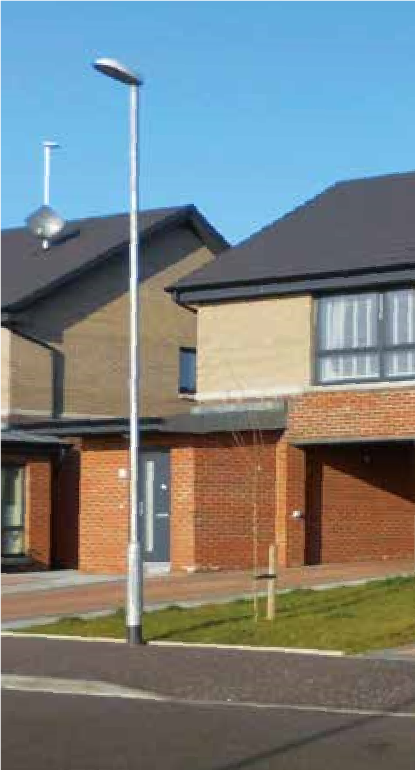
Financial Services Authority: Reg No. 2420, Scottish Charity No: SCO41911
Ruchazie Housing Association
24
Avondale Street
Ruchazie
Glasgow G33 3QS
Tel:
0141 774 4433
Fax:
0141 774 0207
Email: admin@ruchazieha.co.uk
Web:
www.ruchazieha.co.uk

