|  |
| --- |
| Applicant Key: |

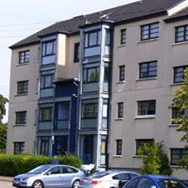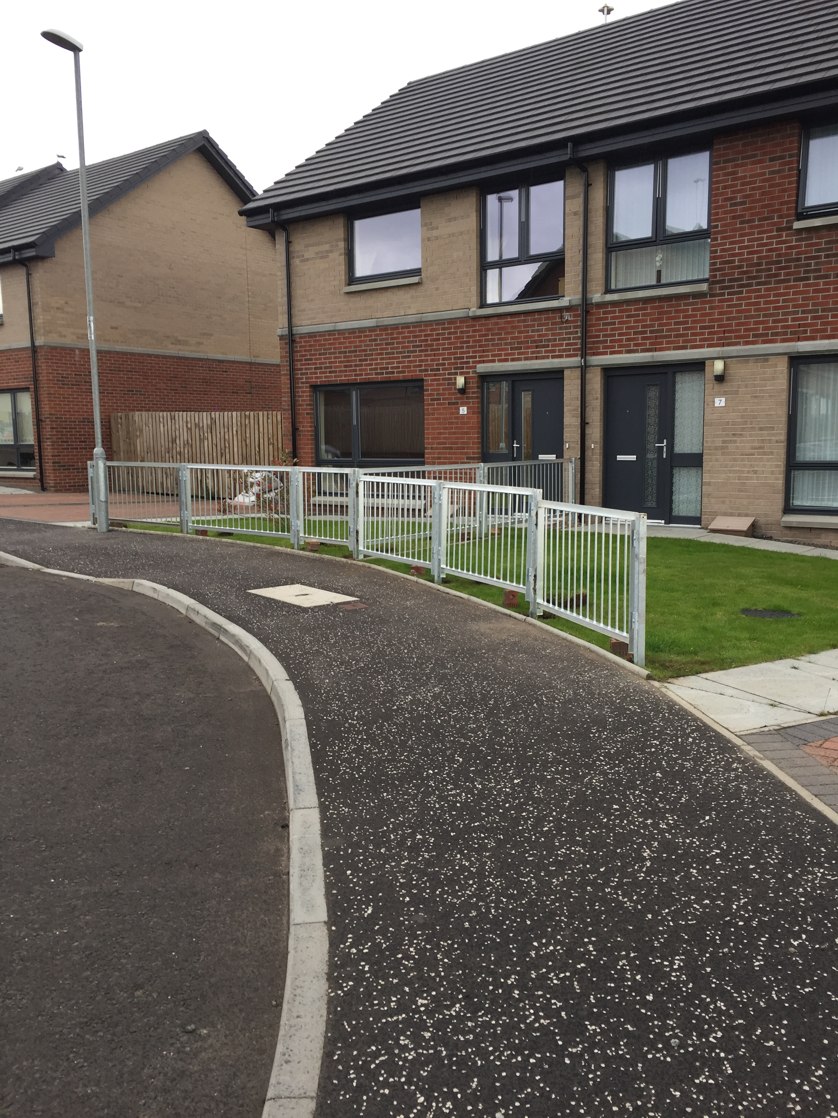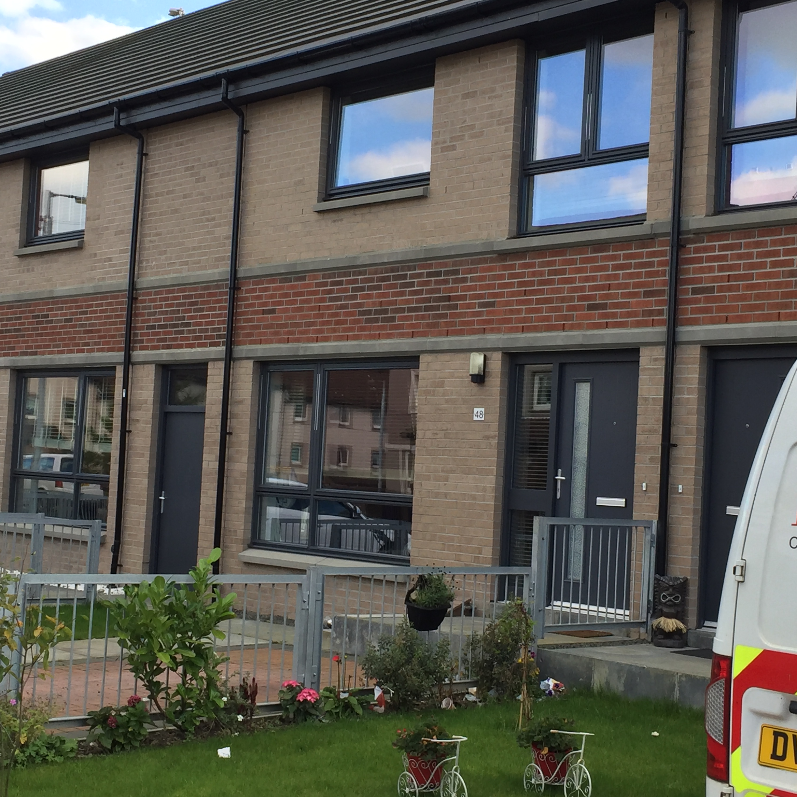

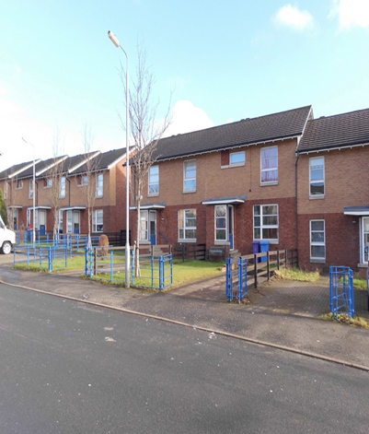

|  |  |
| --- | --- |
| Received : |  |
| Apartment size : |  |
| Property type required : |  |
| Total Points : |  |

* **Please note that you must provide evidence in support of your application**
* **Details can be found under each section & attached supporting evidence sheet**
* **We can refuse or withdraw offers if you provide inaccurate information**
* **Failing to provide the correct evidence may cause delays in processing your application, these delays may lead to you missing out on offers of housing.**

|  |  |
| --- | --- |
| All applicants | Proof of identity   * Proof of current address (2 items) * Photographic ID |
| All household members | Proof of current address  Proof of ID (passport, driving licence, birth certificate) |
| Asked to leave current accommodation | Notice to quit |
| In need of housing for health reasons affected by current housing circumstance | Completed medical form  Up to date relevant medical information  Other supporting information ( if available) |
| Residency | Bank statement  Driving licence  Tenancy agreement |
| Access to children where additional bedrooms are required for overnight residence. | Letter from parent  Legal confirmation |
| Experiencing harassment | Corroborating evidence from   * Police * Landlord * Other agency |
| Pregnancy | MAT B1 form or similar confirming due date |
| Owners | Proof of intent to sell  Confirmation that applicant cannot return to the property |
| People from Abroad | Immigration Status |

**Verifying an applicant’s circumstances**   
  
**To enable the correct housing need assessment to be made, we generally require applicants to provide information to verify their circumstances. Examples of the verification required include the following, however this list is not exhaustive.**

**It is the responsibility of the applicant to supply the relevant documents to support their application and update their details if there is a change in circumstance.**

**Personal Details**

|  |  |  |  |
| --- | --- | --- | --- |
| **Main applicant** | | **Joint Applicant(if applicable)** | |
| **Full name:** | | **Full name:** | |
| **Date of birth:** | | **Date of birth:** | |
| **Address:** | | **Address:** | |
| **Flat Position:** | **Postcode:** | **Flat Position:** | **Postcode:** |
| **Tel home:** | | **Tel home:** | |
| **Tel mobile:** | | **Tel mobile:** | |
| **Email:** | | **Email:** | |
| **National insurance no:** | | **National insurance no:** | |

**Please provide the following for the main and joint applicant:**

**Proof of identity (birth certificate, passport, driving licence)**

**Proof of current address (2 forms dated within the last 3 months)**

**People to be rehoused with you**

|  |  |  |  |  |
| --- | --- | --- | --- | --- |
| Name | Date of birth  DD/MM/YY | Relationship to applicant | Current address if different from applicant | Please tick if children are access only |
|  |  |  |  |  |
|  |  |  |  |  |
|  |  |  |  |  |
|  |  |  |  |  |
|  |  |  |  |  |

|  |  |
| --- | --- |
| Is anyone in the household pregnant:  Yes No | If yes provide due date of baby: |

**Please provide the following for all people to be rehoused with you:**

**Proof of identity (birth certificate, passport, driving licence)**

**Proof of current address (2 forms dated within the last 3 months**

**Proof of pregnancy (MAT B1 form or similar confirming due date)**

|  |
| --- |
| **Access to Children**  If you have access to children please give brief details below:  For access to children where additional bedrooms are required for overnight residence provide the following:  Letter from other parent or  Legal confirmation |

**People in your current home who will not be rehoused with you**

|  |  |  |  |
| --- | --- | --- | --- |
| **Name** | **Date of birth**  **DD/MM/YY** | **Relationship to applicant** |  |
|  |  |  |  |
|  |  |  |  |
|  |  |  |  |
|  |  |  |  |
|  |  |  |  |

**Current Address**

|  |  |
| --- | --- |
| **What is your current tenure (e.g. tenant, owner, lodger):** |  |
| **Who is your current landlord:** |  |
| **Landlord address:** |  |
| **Date of entry:** |  |

|  |
| --- |
| **How many bedrooms are in your current accommodation?**  **----------------------------------------------------------------------------------------------------** |

**Main applicant: previous addresses**

|  |  |
| --- | --- |
| **Have you ever lived in a property owned by Ruchazie Housing Association** | Yes No |
| **Address:** | **Date of entry:**  **Date of leaving:** |
| **Please provide your reason for leaving:** |  |

**Previous addresses:**

**Please provide details of your addresses for the last 5 years**

|  |  |  |  |  |
| --- | --- | --- | --- | --- |
| **Address** | **Landlords name and address** | **Tenant/lodger/owner** | **Date of entry and leaving** | **Reason for leaving** |
|  |  |  |  |  |
|  |  |  |  |  |
|  |  |  |  |  |
|  |  |  |  |  |
|  |  |  |  |  |
|  |  |  |  |  |
|  |  |  |  |  |

**Have you ever been evicted:** Yes No

If yes, give details:

**Joint applicant: previous addresses (if applicable)**

|  |  |
| --- | --- |
| **Have you ever lived in a property owned by Ruchazie Housing Association** | Yes No |
| **Address:** | **Date of entry:**  **Date of leaving:** |
| **Please provide your reason for leaving:** |  |

**Joint Applicant previous addresses:**

**Please provide details of your addresses for the last 5 years**

|  |  |  |  |  |
| --- | --- | --- | --- | --- |
| **Address** | **Landlords name and address** | **Tenant/lodger/owner** | **Date of entry and leaving** | **Reason for leaving** |
|  |  |  |  |  |
|  |  |  |  |  |
|  |  |  |  |  |
|  |  |  |  |  |
|  |  |  |  |  |
|  |  |  |  |  |
|  |  |  |  |  |

**Have you ever been evicted:** Yes No

If yes, give details:

**Homelessness**

|  |  |
| --- | --- |
| **Do you consider yourself to be homeless?** Yes No | |
|  | |
| **Have you been assessed by your local authority?** Yes No | |
| **If yes please provide a copy of the assessment letter** | |
| **If yes please provide the name of your caseworker and area office:** | |
| **Name of caseworker:** | **Address of area officer:** |
| **Why have you become homeless?** | |

**HOMELESS OR THREATENED WITH HOMELESSNESS**

If you consider yourself to be homeless or threatened with homelessness you should contact Glasgow City Council for housing advice.   
  
To access this service you can contact this service direct. They deliver a homelessness service to anyone who is homeless, threatened with homelessness, or is in need of advice about homelessness issues, through their Community Homeless Services. If you think you are homeless, or at risk of becoming homeless, they will make sure that you are offered an interview at your local Community Homeless Team, or out with normal office hours at the Hamish Allan Centre. If you have nowhere to stay, or are not able to stay in your home and are eligible for homelessness assistance, they may offer you temporary accommodation. There are different types of temporary accommodation throughout Glasgow including assessment centers, projects, temporary furnished flats, supported accommodation and at times Bed and Breakfast type accommodation.  
  
South Community Homeless Service 0141 276 8201  
North East Community Homeless Service 0141 276 6153  
North West Community Homeless Service 0141 276 6168  
Refugee Support Service 0141 276 8245

**Present Accommodation: Main Applicant**

|  |  |  |  |  |  |
| --- | --- | --- | --- | --- | --- |
| **Does your property the following?** | | | | | |
| **Central heating** | | **Double glazing** | | **Sink with hot and cold water** | |
| **Do you share any of the following with another household?** | | | | | |
| **kitchen** | **living room** | | **bathroom** | | **bedroom** |
| **Does your house suffer from dampness** yes no | | | | | |
| **Has this been reported to your landlord?** yes no | | | | | |
| **Does your property have any serious disrepair that is making it difficult for you to live there?** Yes No | | | | | |
| **If yes, please provide details:** | | | | | |

**Present Accommodation: Joint Applicant**

**(Only complete if address if different from main applicant)**

|  |  |  |  |  |  |
| --- | --- | --- | --- | --- | --- |
| **Does your property the following?** | | | | | |
| **Central heating** | | **Double glazing** | | **Sink with hot and cold water** | |
| **Do you share any of the following with another household?** | | | | | |
| **kitchen** | **living room** | | **bathroom** | | **bedroom** |
| **Does your house suffer from dampness** yes no | | | | | |
| **Has this been reported to your landlord?** yes no | | | | | |
| **Does your property have any serious disrepair that is making it difficult for you to live there?** Yes No | | | | | |
| **If yes, please provide details:** | | | | | |

|  |
| --- |
| **Social Support**  **Do you want to move to the area to give support to, or receive support from, someone who lives within the Ruchazie area? Yes No**  **If yes please provide support information:**  **Name:**  **Address:**  **Detail of support given or received:**  **Please provide the following for this section;**   * **Medical evidence** * **Letter to support this information** |
| **Location needs**  **Do you want to move closer to your place of employment, training, education or voluntary work? Yes No**  **If yes, please provide details:** |
| **General information**  **Arrears – are you in arrears with your current landlord/ mortgage lender?**  **Yes No**  **If yes, please provide details of the repayment plan agreed to reduce and clear the arrears** |
| **Anti-social behavior – in the past 6 months has any action been taken against you, or anyone who will be rehoused with you, for anti-social behavior?**  **Yes No**  **If yes, please provide details** |

|  |  |
| --- | --- |
| **Criminal convictions – do you, or anyone who will be rehoused with you, have any criminal convictions which are not spent under the rehabilitation of offenders act 1974?** | **Yes No** |
| **Sex offenders – are you or anyone who will be rehoused with you, on the sex offenders register?** | **Yes No** |
| **Harassment – are you currently being harassed at your present address, and feel you would have a better quality of life if you moved to the Ruchazie area?** | **Yes No** |
| **Relationship breakdown – are you applying for housing as a result of separating from your current partner?** | **Yes No** |
| **Please provide information here:** | |
| **Referrals – are you being referred to Ruchazie Housing Association by a specialist body (e.g. social work or other support agencies)**  **Yes No** | |
| **Please provide information here:** | |

**Medical Support Needs**

|  |  |  |  |  |  |  |
| --- | --- | --- | --- | --- | --- | --- |
| **Name:** | | | | | | |
| **Disability/Condition:** | | | | | | |
| **Do you (or any member of your household included in the application) require rehousing due to medical reasons** | | | | | **Yes No** | |
| **If yes, please provide details:** | | | | | | |
| **Do you/they currently have any adaptions in your/their current home?** | | | | | **Yes No** | |
| **If yes, please provide details:** | | | | | | |
| **Please state how your current home is unsuitable & advise how a move would help improve your/their medical condition (e.g. stairs or on a hill):** | | | | | | |
| **Do you/they have difficulty walking?** | | | **Yes No** | | | |
| **If yes do they use aids to help you/they get around?** | | | **Yes No** | | | |
| **If you/they use a wheelchair, do you/they use it indoors and outdoors?** | | | **Yes No** | | | |
| **Do you/they have trouble climbing stairs?** | | | **Yes No** | | | |
| **If yes how many stairs can you/they manage comfortably?** | | |  | | | |
| **How many stairs are in your/their current home? inside** | | |  | | | |
| **How many stairs are in your/their current home? outside** | | |  | | | |
| **Do you/they have to go upstairs to the .**  **Toilet**  **Bathroom**  **Bedroom** | | | **Yes No**  **Yes No**  **Yes No** | | | |
| **Does your/they current bathroom have:**  **Bath only**  **Bath and over bath shower only** | | | **Yes No**  **Yes No** | | | |
| **Do your/they have trouble using the bath, shower or toilet?** | | | **Yes No** | | | |
| **Please give more information here:** | | | | | | |
| **Is an extra bedroom required due to your/their medical condition:** | | | **Yes No** | | | |
| **If yes, please explain why below:** | | | | | | |
| **What type of heating do you have in your current accommodation?** | **Gas** | **Electricity** | | | | **Other** |
| **Does this affect your/their medical condition?** | | | | **Yes No** | | |
| **If you/they get regular support from anyone else e.g. relatives, district nurse or community psychiatric nurse, please supply their name, address and contact number and the type of support provided:** | | | | | | |

**If you have a medical disability/condition please provide the following**

* **Up to date medical information**
* **Other supporting documentation from any health care professional**

|  |  |  |  |
| --- | --- | --- | --- |
| **Why are you applying for housing?** | | | |
| **Homeless** | **Unsatisfactory Housing** | **Health** | **Support** |
| **Financial** | **Harassment** | **Location** | **Other** |
| **Please give details for ticking the above boxes and any other information you wish to provide below:** | | | |

**See information to be provided on next page**

|  |  |
| --- | --- |
| All applicants | Proof of identity   * Proof of current address (2 items) * Photographic ID |
| All household members | Proof of current address  Proof of ID (passport, driving licence, birth certificate) |
| Asked to leave current accommodation | Notice to quit |
| In need of housing for health reasons affected by current housing circumstance | Completed medical form  Up to date relevant medical information  Other supporting information ( if available) |
| Residency | Bank statement  Driving licence  Tenancy agreement |
| Access to children where additional bedrooms are required for overnight residence. | Letter from parent  Legal confirmation |
| Experiencing harassment | Corroborating evidence from   * Police * Landlord * Other agency |
| Pregnancy | MAT B1 form or similar confirming due date |
| Owners | Proof of intent to sell  Confirmation that applicant cannot return to the property |
| People from Abroad | Immigration Status |

**Verifying an applicant’s circumstances**   
  
**To enable the correct housing need assessment to be made, we generally require applicants to provide information to verify their circumstances. Examples of the verification required include the following, however this list is not exhaustive.**

**It is the responsibility of the applicant to supply the relevant documents to support their application and update their details if there is a change in circumstance.**

**Regulatory standards of governance**

|  |  |
| --- | --- |
| **Are you or any member of your household related to or otherwise connected with a member of the management committee or staff of Ruchazie Housing Association?** | |
| **Persons name:** | **Relationship to you:** |
| **Please note that an allocation made to a relative of a Committee Member or Employee must be recorded. This information will have no bearing on your application.** | |
| **Notes:** | |

|  |
| --- |
| **Tick the housing type you would require/prefer.**  **What type of housing do you require/prefer?**    **House**  **Flat**  **Cottage Flat**  **What floor level do you require/prefer?**    **Ground Floor**  **First Floor**  **Second Floor**  **Third Floor**  **No Preference** |

**Declaration**

|  |  |
| --- | --- |
| **I/We certify that the information given in this application is a true record of my/our present circumstances. I consent to Ruchazie Housing Association making any enquiries as may be necessary, to verify the information provided in this application.**  **I/We understand any false or misleading information, or relevant information being withheld, may result in:**   1. **The application being cancelled and removed from the housing list** 2. **An offer of tenancy being immediately withdrawn** 3. **Legal proceeding being taken for repossession of the tenancy if a tenancy has already been granted**   **I agree to notify the association of any change in my/our circumstances described in this application** | |
| **Applicant Signature** | **Date** |
| **Joint Applicant Signature** | **Date** |



Ruchazie Housing Association Ltd is registered in Scotland with the Scottish Housing Regulator. Reg No: HVB 277