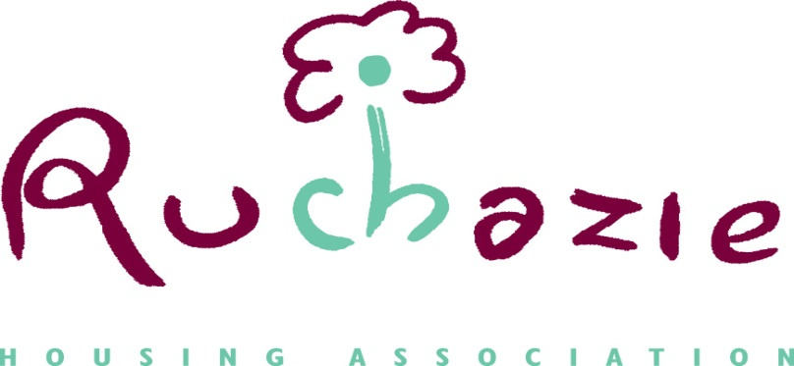

RENT INCREASE CONSULTATION
2019/20

Rent increase proposal

We are asking our tenants for their opinion on the following rent increases and what each increase will represent.

The figures below provide examples of what an increase of 2.9% or 3% will have on the amount of monthly rent paid on Ruchazie properties of different sizes.

2.9% will allow the Association to deliver our services.
3% will allow the Association provides for additional money to invest in your home perhaps at an earlier date than anticipated, but this would increase your rents by slightly more at this time.
Any increase less than 2.9% would mean the Association would not be able to make improvements to your home.

House Size | Current average Rent (weekly) | 2.9% | diff | 3% | diff
2 Apt | £64.62 | £66.49 | £1.87 | £66.58 | £1.96
3 Apt | £70.37 | £72.41 | £2.04 | £72.48 | £2.11
4 Apt | £73.01 | £75.13 | £2.12 | £75.20 | £2.19
4 Apt Flat | £70.25 | £72.28 | £2.03 | £72.35 | £2.10
5 Apt + | £81.26 | £83.61 | £2.35 | 83.70 | £2.44

The average rent increase at 2.9% would be £9.02 monthly and the average rent increase for 3% would be £9.36 monthly.

There is no increase in the stair cleaning charge, the cost for stair cleaning at £6.50 each month is not reflected in this table, if you receive a stair cleaning service you should include this charge.

Our costs change year on year. This year for example there have been additional costs for Regulation and this will perhaps continue further into 2019, Consideration also has to be given to the costs in supporting tenants affected by Welfare Reform; the types of loans our lenders offer and the impact political decisions have on housing.

In 2019-2020 we want to focus on these areas:

- Making improvements to your homes. We plan to replace boilers in properties in Phase 2 and we will continue with our kitchen replacement programme in Phase 3.

- Improving our stock to meet the new Fire Safety Standards with the installation of additional smoke alarms and heat sensors in your home.

- Continue to support our tenants through the introduction of Universal Credit.

How each £1 of income is spent

The rent you pay is the only source of income the Association has. This income is used for repairs to your home, investments to your property such as new kitchens, bathrooms and boilers, wider role activities supporting local groups, competitions throughout the year and staffing costs. The table below indicates how each pound of your rent is spent by the association.

Management Costs
Staff salaries, pensions, office overheads and wider role expenditure
Loan repayments
Interest on loans taken out to build new homes
Reactive maintenance
Day to day repairs and services
Cyclical maintenance
Gas servicing, paintwork, gutter cleaning and electric checks.
Planned maintenance
Kitchen replacements, new door entries etc.
Property Insurance
Money we pay to protect our buildings (tenants responsible for insuring contents)
Surplus/deficit
Money that is retained for investment into our properties provide.

The Association always takes a careful and prudent approach to all financial matters, including rent setting. What you pay in rent supports the delivery of services. We are mindful of decisions we make and how they affect our tenant’s ability to pay and meet other household expenses. . Ruchazie Housing Association rents remain among the lowest in Easterhouse, particularly for larger families. Our average weekly rent for 2017/2018 was £71.86, compared to other similar sized landlords in the area of £76.88. We are able to continue to provide high quality services and contribute to the regeneration of the wider Easterhouse area through the Easterhouse Housing and Regeneration Alliance (EHRA).

Remember if you receive housing benefit, the rent increase will automatically covered by your entitlement to this benefit. If you think you are entitled to Housing Benefit please contact us at the office where we will be able to support your application.
HAVE YOUR SAY

Last year we received 26 responses to our consultation and we hope that all tenants will take the time to consider our proposals. Nothing has been decided as yet. The Management Committee will make a decision at its meeting on the. We would like to hear your views as this will help the Management Committee decide what rents should be set at. Please let us have your views and comments by Monday 20th January 2019.

- You can also call in for chat at our office which will be open on Thursday 17th January until 6pm.

Tenant Questionnaire

- Do you understand everything that has been explained here in this leaflet regarding your proposed rent increase?

YES/NO
If No Can you say why?
______________________________________________________________________
______________________________________________________________________

- What increase of rent would you like to see, taking into account the services we would like to provide.

Please tick
2.9%
3%

Comments
______________________________________________________________________
______________________________________________________________________

- Is there any other information you would like to receive regarding our rent charges and services?

______________________________________________________________________
______________________________________________________________________

Once you have completed this page, please return to our office at 24 Avondale Street, Ruchazie.
You can also contact us in the following way
By completing the questionnaire attached or online at www.surveymonkey.
By email to administrator@ruchazieha.co.uk
Via our online survey at www.ruchazieha.co.uk
Via our Facebook and Twitter pages

