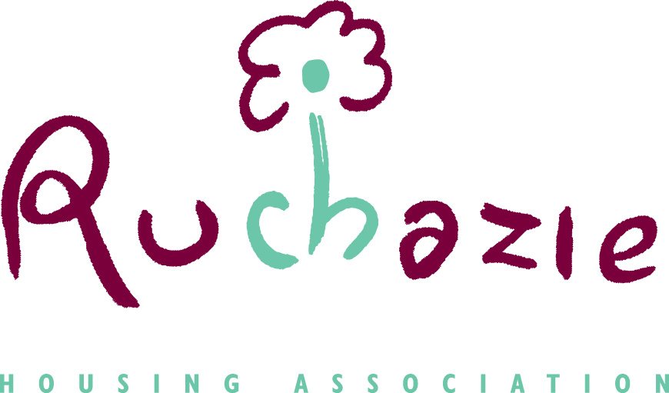

RUCHAZIE HOUSING ASSOCIATION
RISK MANAGEMENT POLICY

Date of Policy | October 2019
Date approved by Management Committee | 28th October 2019
Date for review | September 2022

INDEX

Section | Area | Page
1 | purpose of the Policy | 3
2 | why we manage risk | 3
3 | definitions | 4
4 | risk management aims and objectives | 4
5 | underlying approach to risk management | 4
6 | roles and responsibilities | 5
7 | risk appetite | 7
8 | risk management process | 7
9 | RISK MANAGEMENT AS PART OF THE SYSTEM OF INTERNAL CONTROL | 11
10 | ANNUAL REVIEW OF EFFECTIVENESS | 12
11 | APPENDIX A – Risk Management Reporting and Escalating | 14
12 | APPENDIX b – RISK SCORING MATRIX and scoring criteria | 15
13 | APPENDIX C – Risk Management Reporting Cycle | 18
14 | APPENDIX D – Glossary & Risk Categories | 19

- Purpose of this document

This Risk Management Policy forms part of the internal control and corporate governance arrangements of Ruchazie Housing Association (RHA).

The policy explains RHA’s underlying approach to risk management, and documents the roles and responsibilities of the governing body and staff. It also outlines key aspects of the risk management process and identifies the main reporting procedures.

- Why We Need to Manage Risk
The focus on risk management as part of the process of good governance, effective business planning and safeguarding assets takes account of the Scottish Housing Regulator’s Standards of Governance and Financial Management for RSLs (2019).

The Regulator requires that RHA has an effective risk management and internal controls assurance framework in place. We demonstrate this through the annual ‘Internal Controls Assurance’ statement approved by the committee and included in RHA’s financial statements. An effective Risk Management Policy is an integral part of this assurance and is crucial to supporting the statement. RHA will continue to focus on embedding risk management throughout the organisation by putting in place a pro-active risk management framework

Risk Management is beneficial to RHA as it:

- helps us to be more flexible and responsive to new internal / external demands;
- helps make informed decisions;
- provides assurance to the governing body and management;
- reduces incidents and other control failures; and
- helps in the achievement of RHA’s key targets and priorities

Managing the risks to our business objectives reduces the chance of us having to deal with the unexpected and ensures proactive management rather than reactive crisis management. At a time when resources are limited it is especially important to reduce the number of unwanted surprises.

The framework for managing risk sets out the process through which risks will be identified, assessed, controlled, monitored and reviewed. The framework is designed to:

- Integrate risk management into Arklet’s culture;
- Raise awareness of the need for risk management;
- Encourage a positive approach to risk management;
- Support improved decision making, innovation and performance, through a good understanding of risks and their likely impact; and
- Manage risk in accordance with best practice.

- definitions

What is a risk?

“The threat or possibility that an action or event will adversely affect an organisation’s ability to achieve its objectives”.

What is risk management?

“Risk Management is the process which aims to help RHA understand, evaluate and take action on all our risks with a view to increasing the probability of our success and reducing the likelihood of failure”.

- Risk Management Aims and Objectives

- Provide continuous high quality services to RHA customers & tenants.
- Use appropriate identification and analysis techniques to identify risks to RHA and determine the long and short-term impact.
- Prioritise and implement economic control measures to reduce or remove risks.
- Protect and promote our reputation.
- Through the use of training and communication, develop and maintain a structured risk management culture, where risk is considered in the decision making process and the everyday working situations of all staff.
- Maintain a system for recording and providing accurate, relevant and timely risk management information.
- Reduce the long-term cost of risk to RHA.
- Report on and review the Risk Management Policy in accordance with best practice guidelines.

- Underlying approach to Risk Management

The following key principles underlie RHA’s approach to risk management and internal control:

- The governing body has responsibility for overseeing risk management within RHA as a whole;
- An open and receptive approach to solving risk problems is adopted by the committee;
- The Director and staff team support, advise on and implement policies approved by the committee;
- Risk management forms part of RHA’s system of internal control;
- RHA makes conservative and prudent recognition and disclosure of the financial and non-financial implications of risks;
- All staff are responsible for encouraging good risk management practices within their areas of responsibility.
- Roles and responsibilities

ROLE OF THE GOVERNING BODY (Management Committee)

The management committee has a fundamental role to play in the management of risk.
Its role is to:
  - Set the tone and influence the culture of risk management within RHA.
This includes:
- determining whether RHA is ‘risk taking’ or ‘risk averse’ as a whole or on any relevant individual issue
- determining what categories of risk are acceptable and which are not
- Setting the standards and expectations of staff with respect to conduct and probity.
  - Determine the appropriate risk appetite or level of exposure for RHA.
- Approve major decisions affecting RHA’s risk profile or exposure.
- Monitor the management of significant risks to reduce the likelihood of unwelcome surprises.
- Satisfy itself that the less significant risks are being actively managed, with the appropriate controls in place and working effectively.
- Periodically review the Association’s approach to risk management and approve changes or improvements to key elements of its processes and procedures.

AUDIT & Risk Committee

The Audit & Risk Committee (if subsequently agreed to be part of the governance framework) will at each of its scheduled meetings receive an update report on RHA’s Strategic Risks and Operational Risks in accordance with the reporting cycle (Appendix D). Its role is to:-

- Monitor the management of high level risks
- Review the Risk Appetite of RHA and make recommendations to the governing body.
- Satisfy itself that all known risks are being actively managed, with the appropriate controls in place and working effectively
- Annually review the group’s approach to risk management and approve changes or improvements to key elements of its processes and procedures.

Role of the director (SUPPORTED BY THE staffTEAM )

- To ensure that RHA manages risk systematically, economically and effectively through the development of an all-encompassing Risk Management policy.
- To support RHA in the development, implementation and review of the Risk Management policy.
- To share experience on risk, risk management and policy implementation.

Responsibilities

- To acquire a knowledge of risk management and its benefits.
- Monitor, evaluate and update RHA’s Strategic Risk Register at least once a quarter
- Report to each meeting of Audit & Risk Committee (where appointed) on the status of risks and controls.
- Ensure risk management and its processes are disseminated and are embedded throughout RHA
- Preparation of relevant contingency plans in those areas that are considered high risk.
- To review any training requirements to enable the development & implementation of risk management.
- To contribute to the management of risk in their own service area / department .
- To review and update their risks at team meetings in accordance with the reporting cycle (Appendix D) .
- To disseminate the detail of the policy and allocate responsibilities for implementation of the policy in each service area / department.
- To identify any risk management issues in their service area / department.
- To ensure that the policy is implemented across their service areas / departments.

The Director will take overall responsibility for the administration and implementation of the risk management process across the Association.

All staff regarding Risk Management

All staff have a duty to ensure that risk is managed effectively in their area. This includes engagement with colleagues through formal and informal processes.

All RHA staff have a responsibility for identifying risks in performing their daily duties and taking action to limit the likelihood and impact of these risks.

- RISK APPETITE

The success of RHA is a result of effectively managing our key risks, which in turn support the achievement of our key targets and priorities. RHA acknowledges that an element of risk exists in all activity it undertakes.

Risk appetite is defined as the amount of risk an organisation is prepared to tolerate or be exposed to, should the risk be realised. Too great a risk appetite can jeopardise a project or activity whilst too little could result in lost opportunity.

RHA’s risk threshold is when the risk is ranked category B or above after controls have been applied (‘Red’ on the risk scoring methodology – Appendix B). Above this threshold, RHA will actively seek to manage the risk and will prioritise time and resources to reducing, avoiding or mitigating these risks.

The Audit & Risk Committee (if appointed) will then agree the risk appetite (what level of risk is acceptable) for RHA and the appropriate level of risk mitigation activity for each risk in this category.

A risk owner will be designated for each risk on the risk register. Risk owners will ensure that their action plan addresses the risks identified and will be required to monitor the status of their portfolio of risks in accordance with the reporting cycle (Appendix C). Risk owners will be reviewed on an annual basis.

- RISK MANAGEMENT PROCESS

The group’s risk management process features the following five steps:

Step 1 – Identify Risks

Using RHA’s Strategic or Operational Plan objectives, identify the potential threats that could jeopardise their achievement and in turn look at ways to manage these risks.

Risk identification attempts to identify our exposure to uncertainty. The Director and staff team are ultimately responsible for identifying the risks that they may face.

Having identified the risks, these are recorded on the Risk Register template. Where appropriate however, a project level risk register will be maintained for a specific strategic initiative such as a new capital project.

Risks shall be identified at all levels of RHA:

- Strategic - Where threats and opportunities could affect decisions on RHA’s strategic objectives;
- Operational - Where threats and opportunities could affect decisions on operational actions to meet RHA’s strategic objectives;
- Project Level - Where threats and opportunities could affect the delivery of project targets. (E.g: entering into major service contracts or partnerships). Before committing to a new business activity, appropriate specialist advice will be sought to supplement our own expertise where appropriate – this may include seeking legal and other professional advice.

Equalities

When identifying risk, all activities undertaken by RHA must be assessed for their compliance with our Equalities and Diversity Policy. We will seek to ensure that there is no risk of discrimination or unfair treatment as a result of our actions.

Risks, Cause and Effect:

Risks are best expressed using a risk, cause and effect relationship.

Understanding the most important ‘cause’ helps formulate the best possible actions to manage an uncertainty (i.e. treating the root cause instead of the symptom). Understanding the most important effect helps formulate the best possible contingency plan in case an uncertainty does happen with negative impact.

For example: The Butterfly Effect:

CAUSE RISK EFFECT
Why could this risk occur? What am I worried about? what could happen if the risk occurred?

Cause 2
Out of date policies
Cause 1
Lack of training and awareness
Effect 1
Financial penalties

Effect 2
Reputational damage
Fail to Manage Health & Safety Effectively

Cause 3
No / inadequate risk assessments
Effect 3
Contractor / Staff / Visitor Injury

From this example we can clearly see what the risk is and also 3 potential causes as to why this risk could occur. We can also see 3 potential effects on Arklet if this risk was to materialise, therefore if this risk was to be placed on a risk register we would expect to see 3 controls in place:-

Control 1 | RHA has an extensive and up to date training programme and induction programme that provides all staff with regular training on Health & Safety
Control 2 | All Health & Safety policies are up to date and all staff have been issued with, or have access to copies.
Control 3 | RHA uses a consultant Health & Safety Specialist that undertakes regular audits and inspections to ensure it is compliant with the up to date legislation

Step 2 – Assess Risks

Emerging risks will be identified and discussed by RHA’s staff team on an on-going basis. Any information that impacts upon RHA’s risk profile shall be formally assessed and appropriate action identified and monitored in line with the framework identified in Appendix B.

Risks are assessed by looking at the likelihood of the risk occurring and the impact that the risk would have if it were to occur.

Many controls are in place to minimise identified risks. However, in the first instance, risks are assessed as though there are no controls in place i.e. the worst case scenario or if the controls in place were ineffective. This is known as the ‘Inherent’ risk level. The Inherent risk level is recorded in the risk register.

In most scenarios however, there will be controls in place to minimise the impact or likelihood of the identified risk occurring. Risks are therefore assessed based on the Impact and likelihood of the risk occurring considering that there are mitigating controls in place. This is known as the ‘Residual’ risk level.

Each risk is allocated a risk owner / risk lead whose name is recorded on the risk register. Guidance on how the Impact and likelihood levels of a risk should be assessed can be found in Appendix B

Step 3 – Prioritise Risks

Some risks command a higher priority due to their likelihood and impact.

Both the Inherent and Residual likelihood and impact levels of each risk are plotted and prioritised using a 5 by 5 matrix (See Appendix B).

A ‘traffic light’ system is then used to show Category A to E risks. This results in the prioritisation of both Inherent and Residual risks, which are recorded in the Risk Register.

Step 4 – Control Risks

Once the category of a risk has been assessed RHA’s risk appetite should indicate how the risk is then managed. In managing the risk there will be four categories of response – transfer, treat, terminate and tolerate. Details of each response can be found in the following table:

Response | Description
Transfer | Risks are transferred to an insurer, e.g., legal liability. However it must be remembered that this is not possible for all risks.  Some service delivery risks can also be transferred to a partner or contractor by way of a formal contract or written agreement.  Some aspects of risk however cannot be transferred, for example those that have a reputational impact.
Treat | Risks need additional treatments (controls) to reduce the likelihood and impact levels.  This response is most likely where the risk has been identified as a high risk due to the likelihood and impact levels and RHA has the ability to introduce further controls that will reduce the likelihood and/or the impact of a risk.
Terminate | A risk maybe outside RHA’s risk appetite and we do not have the ability to introduce additional controls to reduce likelihood and/or impact of the risk therefore there is no other option than to terminate the activity generating the risk.
Tolerate (accept) | The controls in place reduce the likelihood and impact levels to an acceptable level (within appetite) and the introduction of additional controls would not be cost-effective. It is therefore decided to tolerate the risk.

Red Risks
- Risks that fall in to the area highlighted as 15 and above will require immediate attention. The status of the risk will require it to be monitored with regard to effect on RHA’s activities and the progress of action taken to ensure its effective reduction.

Amber Risks
- Risks that fall in to the area highlighted as amber will require actions where possible and be monitored for any changes in the risk or control environment which may result in the risk attracting a higher score.

Yellow Risks
- Risks that fall in to the area highlighted as yellow will require to be monitored but do not require actions

Green Risks
- Risks that fall in to the area highlighted as green will require annual review only, but no further action.

Risk owners are responsible for:
- ensuring that appropriate resources and importance are allocated to the process;
- confirming the existence and effectiveness of the mitigating controls and ensuring that any proposed mitigating actions are implemented;
- Providing assurance that the risks for which they are Risk Owner are being effectively managed.

Step 5 – Assurances

RHA will identify and implement appropriate controls to manage the risks identified. It will also implement processes to give assurance that these controls are working effectively.

What is Assurance?

Assurance:
Provides: | “Confidence” / “Evidence” / “Certainty”
To: | Management / The Audit & Risk Committee (where appointed) / the governing body (individually and collectively)
That: | That what needs to be done (strategically and operationally) is being done

1st, 2nd and 3rd Lines of Assurance
The assurances that RHA receives can be broken down into the three line model as illustrated below

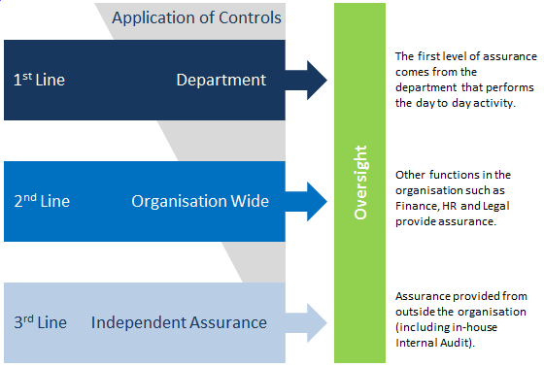

- Risk Management as part of the system of internal control

The system of internal control incorporates risk management. The system encompasses a number of elements that together facilitate an effective and efficient operation, enabling RHA to respond to a variety of operational, financial and commercial risks. These elements include:

- Policies and Procedures | Attached to significant risks (e.g. Fire / Health & Safety) are a series of policies that underpin the internal control process. Written procedures support the policies where appropriate
- Reporting | The Director and the Audit & Risk Committee (where appointed) receive a number of key reports on a regular basis which allow for the monitoring of key risks and their control – e.g. the monthly management accounts / safeguarding
Business Planning and Budgeting | The business planning and budgeting process is used to set objectives, agree action plans and allocate resources – these take account of risk. Progress towards meeting business plan objectives is monitored regularly
- Project Management | All approvals for the execution of new projects include an examination of risk in accordance with the risk appetite of the governing body set out in the financial regulations
- Audit & Risk Committee | The Audit & Risk Committee (where appointed) is required to report to the governing body on internal controls and to alert members to any emerging issues. As part of this function the Audit & Risk Committee oversees internal audit and external audit – otherwise this responsibility falls to the governing body.
- Internal Audit Programme | Internal audit is an important element of the internal control process. It will include a review of the effectiveness of the internal control system in its Annual Report. The annual internal audits should be set based on a risk based approach.
- External Audit | External Audit provides feedback on the operation of the internal financial controls and provides an update to the governing body.
- Third Party Reports | On occasions other agencies and consultants will provide reports which will make reference to the effectiveness of the internal control systems

- Annual review of effectiveness

The governing body is responsible for ensuring that there is an annual review of Arklet’s risk management processes, (this will be undertaken initially by the Director who will report to the Audit & Risk Committee) including on-going identification and evaluation of significant risks and the allocation of resources to address areas of high exposure.

The governing body will:

- Review RHA’s track record on risk management and internal control over the previous year.
- Consider the internal and external risk profile of the coming year and consider if current internal controls are likely to continue to be effective.

In making its decision the governing body will consider the following aspects:

- Control Environment
  - RHA ’s objectives and its financial and non-financial targets
  - Organisational structure and calibre of the staff team
  - Culture, approach and resources with respect to the management of risk
  - Delegation of authority within RHA

- On-going identification and evaluation of risk
  - Timely identification and assessment of risks, prioritisation of risks and the allocation of resources to address areas of high exposure

- Information and Communication
  - Quality and timeliness of information on risks, the time it takes for control breakdowns to be recognised or new risks to be identified.

- Monitoring and Corrective Action
  - Ability of RHA to learn from its problems.
  - The commitment and responsiveness with which corrective actions taken are implemented.

Management will also annually review the effectiveness of RHA’s internal control system.
A full Internal Controls Assurance report will be produced annually for consideration initially by the Audit & Risk Committee (where appointed) and ultimately by the management committee.

Appendix A - Risk Management Reporting and Escalating

The Governing Body
Receives Assurance report on the Strategic Risks / overview of high Level Operational Risks

Audit & Risk Committee (if appointed)
Advises the Governing Body on the RHA arrangements for risk management
Staff Team – Team Risk Registers

Director (Supported by staff team)
Prepares Strategic Risk & Assurance Reports / High Level Operational Risks and Reports for Committee
All Staff input into Team Risk Registers
Via team meetings and discussions with management

APPENDIX B – Risk Matrix and Scoring Criteria –

RISK | Likelihood
Impact | 1 | 2 | 3 | 4 | 5
 | Rare | Unlikely | Possible | Likely | Almost Certain
5 Major | 15 | 19 | 22 | 24 | 25
4 Significant | 10 | 14 | 18 | 21 | 23
3 Moderate | 6 | 9 | 13 | 17 | 20
2 Minor | 3 | 5 | 8 | 12 | 16
1 Negligible | 1 | 2 | 4 | 7 | 11

IMPACT

Rating | Rating Scale | Safety | Reputation | Media attitude | Scottish Housing Regulator | Legal Action | Staff | Criminal | Direct Loss | Regulatory / Industry Status | Service Quality
NEGLIGIBLE | 1 | No risk of injury. H&S compliant. | External Stakeholders not impacted or aware of problem | No adverse media or trade press reporting. | High compliance standards recognised. | Unsupported threat of legal action | Minimal effect on staff. | High control standards maintained and recognised. | Between 0-£1,000 | No or little change to regulation in recent history/ near future. | Negligible effect on service quality
MINOR | 2 | Small risk of minor injury. H&S policy not regularly reviewed. | Some external Stakeholders aware of the problem, but impact on is minimal. | Negative general Housing Association article of which Arklet is mentioned | Verbal comments received | Legal action with limited potential for decision against | Potential for additional workloads intruding into normal non-working time. | Attempted unsuccessful access to operational systems; minor operational information leaked or compromised. | Between £1,000 and £5,000 | Limited recent or anticipated changes | Marginally impaired – slight adjustment to service delivery required
MODERATE | 3 | High risk of injury, possibly serious. H&S standards insufficient / poor training. | A number of Stakeholders are aware and impacted by problems. | Critical article in Press or TV. Public criticism from industry body. | Findings in written examination report. Potential SHR intervention | Probable settlement out of court | Increase in workloads.  Intrusion into normal non-working time. | Logical or physical attack into’s operational systems. | Between £5,000 and £25, 000 | Modest changes recently or anticipated | Service quality impaired – changes in service delivery required to maintain quality
SIGNIFICANT | 4 | Serious risk or injury possibly leading to loss of life. H&S investigation resulting in investigation and loss of revenue. | Significant disruption and or Cost to Stakeholders / third parties. | Story in multiple media outlets and/or national TV main news over more than one day. | Multiple or repeat governance failings results in SHR intervention | Law suit against for major breach with limited opportunity for settlement out of court | Significant injuries, potential death.  Major intrusion into staff's time. | Police investigation launched; operational data or control systems may be compromised. | Between £25,000 and £100,000 | Potential intervention by lead regulator. Significant changes to industry | Significant reduction in service quality experienced
MAJOR | 5 | Potential to cause one or a number of fatalities. H&S breech causing serious fine, investigation, legal fees and possible stop notice. | Stakeholders / Third parties suffer major loss or cost. | Governmental or comparable political repercussions. Loss of confidence by public. | Action brought against RHA for significant governance failings Forced merger | Action brought against RHA for significant breach. | Deaths and/or major effect on staff lives. | Major successful fraud; prosecution brought against ARHA and Exec for significant failure; Systems totally compromised. | Over £100,000 | Major complex changes to industry Intervention on behalf of the Lead regulator | Complete Failure of Services

LIKELIHOOD
Rating | Rating Scale | Likelihood | Example of Loss event Frequency
RARE | 1 | This will probably never happen / recur | 10 years or less frequently
UNLIKELY | 2 | Do not expect it to happen / recur but it is possible it may do so | Once every 5 years
POSSIBLE | 3 | Might happen or recur occasionally | Once every 2 years
LIKELY | 4 | Will probably happen /recur but it is not a persisting issue | Annually
ALMOST CERTAIN | 5 | Will undoubtedly happen /recur, possibly frequently | At least annually

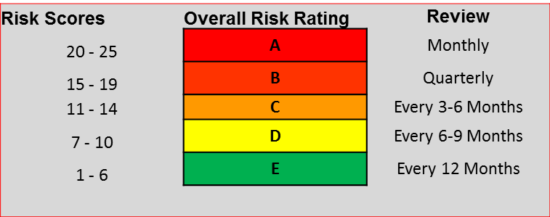

APPENDIX C – Risk Management Reporting Cycle

The table below sets out the risk management reporting cycle:

Risks | The Board | Audit & Risk Committee | Staff team
RHA’s strategic risks | Every Quarter | Each meeting | N/A
Policy and Annual Review | Annually | Annually | N/A
Operational risks which are classified as A | Every Quarter | Each meeting | Team Meetings Monthly
Operational risks which are classified as B | Every Quarter | Each meeting | Team Meetings Quarterly
Operational risks which are classified as C | N/A | Every 6 Months | Team Meetings every 6 months
Operational risks which are classified as D | N/A | N/A | Annually
The remaining operational risks that are classified as E | N/A | N/A | Annually

APPENDIX D – Glossary of Terms & Risk Categories

Term | Definition
Assurance | An opinion based on evidence gained from the review of RHA 's governance, risk management and control framework that risk assessments and control responses are appropriate, adequate and achieving the effects for which it has been designed.
Cause | The reason for the risk exposure – why would a risk occur
Effect | The impact for the risk exposure – what would be the impact if the risk materialised
Exposure | The consequences that arise from the realisation of a risk.
Inherent risk  Score | The classification RHA gives to a risk, based on its likelihood and potential impact and BEFORE the application of a risk response and controls.
Impact | The effect that a risk would have on us if it occurred.
Likelihood | The probability of a risk occurring.
Risk Owner | The person responsible for ensuring the risk is properly managed and monitored
Residual risk  Score | The classification given to a risk AFTER taking into account the quality of risk responses and controls.
Risk | The threat or possibility that an action or event will adversely or beneficially affect an organisation’s ability to achieve its objectives.
Risk appetite | The level of risk RHA is prepared to accept or tolerate before considering action necessary.
Risk assessment | The process by which RHA identifies and assesses the risks associated with its activities within each level of ther business.
Risk management | “Risk Management is the process which aims to help RHA understand, evaluate and take action on all our risks with a view to increasing the probability of our success and reducing the likelihood of failure”.
Risk register | A document for capturing important information about each risk RHA identifies.
Risk response / control | An action or process that RHA currently has in place to either reduce a risk to an acceptable level or increase the probability of a desirable outcome

Risk Category | Definition
Political | Associated with the failure to deliver either central or local government policies, or recognise their priorities; threats from new policies and legislation.
Financial/  Economic | Associated with financial planning and control. Affecting the ability of RHA to meet its financial commitments e.g. internal budgetary pressures, the failure to purchase adequate insurance cover, external macro-level economic changes e.g. market changes.
Social/  Cultural | Relating to the effects of changes in demographic, residential or socio-economic trends on RHA’s ability to respond and meet its objectives.
Technological | Associated with the capacity to deal with the pace/scale of technological change, or RHA’s ability to use technology to address changing demands. This may also include the consequences of internal technological failures on RHA’s ability to deliver its objectives.
Compliance | Related to possible non-compliance through breaches of legislation e.g. SORP non-compliance, illegality, non-compliance with regulatory requirements, with Health and Safety and/or non-adherence to RHA policies and procedures.
Environmental | Relating to the environmental consequences of progressing the organisation’s objectives; energy and fuel efficiency issues; etc.
Commercial | Under performance against contract specification leading to failure or inability to maintain provision; threats from the activities of competitors; partners change priorities.
Tenant/  Customer | Associated with failure to meet the current and changing needs and expectations of tenants, clients and customers e.g. service quality; duty of care, or to expose RHA staff or assets to unnecessary risk.

The above risk category table is added for additional information

