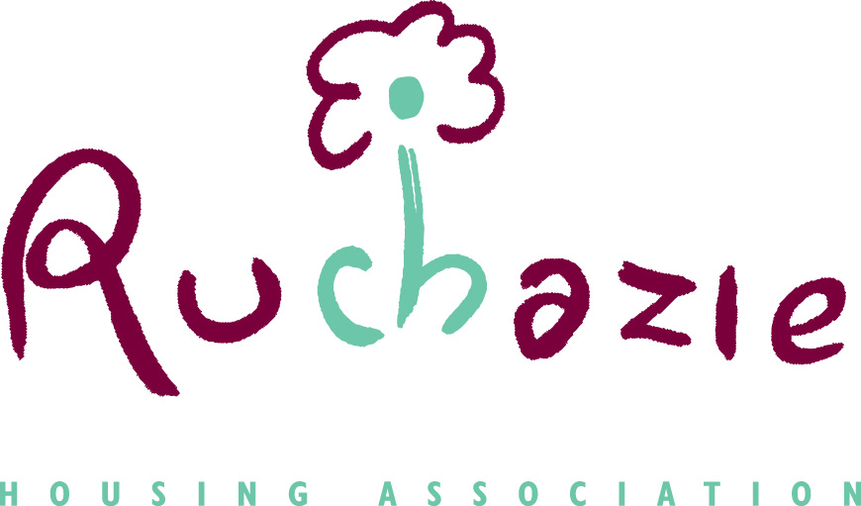

Tenant Engagement Strategy

Date of policy | December 2019
Date approved by Management Committee | 19 December 2019
Date of Review | September 2021
Due for Review | September 2024
- FOREWORD

  - Without the involvement of tenants, it will be very difficult for Ruchazie Housing Association (RHA) to make improvements to our service that our tenants would like to see.

The Management Committee welcome the involvement of all of our tenants, and that includes any constructive criticism they may have. Our aim is to make our tenants and other residents safe, warm and comfortable in their home, and to respond to any concerns they may have in connection with their home and the community they live in. Tenant involvement will help us achieve that aim.
Hugh Holland, Chairperson of Ruchazie Housing Association

  - We welcome the opportunity to work with our tenants and other service users. Effective participation gives tenants an opportunity to influence decisions about the services they receive, and it helps landlords deliver better services that focus on tenant priorities.

Tenant engagement has been a hard nut to crack here in Ruchazie, over the years’ new homes have been built and tenants do not see any need to be involved. We hope to change this and this strategy is a means to involve tenants in the decisions made about their homes.

We will always strive to give our tenants as many opportunities as possible to work with us, so it is important that tenants can input where they feel strongly about something.
Janice Shields, Interim Director

- INTRODUCTION

What is a Tenant Participation Strategy?

A Tenant Participation Strategy is a plan that sets out how we at Ruchazie Housing Association will involve and work with our tenants.

Tenant Participation is about involving our tenants in shaping the housing services they receive and the way their communities are managed. The strategy sets out how we will work with our tenants to provide them with a range of ways to get involved and how our tenants’ views will inform the decisions we make.

Our Commitment to Tenant Participation

We are committed to involving tenants in a meaningful and effective way. To do this, we will:

    - Provide clear information about our services

- Provide opportunities for our tenants to get involved in the things they are most interested in

- Identify and remove barriers so that we open involvement to all tenants regardless of age, disability, race, gender reassignment, marriage and civil partnership, pregnancy and maternity, religion and belief, gender or sexual orientation

- Consult with tenants in a variety of ways most suited to their needs and circumstances

- Provide feedback in a range of formats

- Provide support to develop the skills, knowledge and confidence of all participants

- Monitor and review the strategy

- PARTICIPATION

  - The Housing (Scotland) Act 2001 created a legal framework for tenants who have a Scottish secure tenancy or short Scottish secure tenancy to take part in the way their housing is managed. gave tenants and tenant’s groups the right to be involved and to take part in decisions which affect them, later legislation has strengthened tenants’ rights.

  - The Housing (Scotland) Act 2001 placed a legal duty on local authorities and Registered Social Landlords (housing associations) to have tenant participation strategies in place, and to maintain a register of tenant organisations (RTO’s). The Act introduced a right for tenants’ groups and individual tenants to be consulted by the landlord on issues affecting them. The Act also places duties on landlords to ensure there are ways for tenants to get involved in decisions and to support and resource tenant participation.

  - In addition, the Scottish Social Housing Charter developed by tenants and for tenants, which came into effect in April 2012 and updated in 2017 sets out the outcomes and standards that all landlords in Scotland are expected to meet and the levels of services tenants should expect from their landlord.

    - Ruchazie Housing Association has developed this strategy to ensure that it reflects the outcomes that are specific to Tenant Participation.

  - Outcome 1 Equalities states that- Social landlords perform all aspects of their housing services so that:

‘every tenant and other customer has their individual needs recognised, is treated fairly and with respect, and receives fair access to housing and housing services.

Outcome 2 Communication states that- Social landlords manage their business so that:

‘tenants and other customers find it easy to communicate with their landlord and get the information they need about their landlord, how, and why it makes decisions and the services it provides’.

Outcome 3 Participation states that- Social landlords manage their businesses so that:

‘tenants and other customers find it easy to participate in and influence their landlord’s decisions at a level they feel comfortable with.

  - The Scottish Housing Regulator (SHR) was established in April 2011 under the Housing (Scotland) Act 2010; the SHR is the independent regulator of Registered Social Landlords(RSL’s) and local authority housing services in Scotland. The regulator has one statutory objective, to:

‘safeguard and promote the interests of current and future tenants of social landlords, people who are or who become homeless, and people who use the housing services provided by RSL’s and local authorities’

expects that tenants are at the heart of their organisation.
Regulatory Standard 2 states that:

‘The RSL is open and accountable for what it does, It understands and takes account of the needs and priorities of its tenants, service users and stakeholders. And its primary focus is the sustainable achievement of these priorities.

And in particular the guidance for standard 2.4 outlines that the RSL will seek out the views of tenants, service users and stakeholders and will take account of this information in its plans, strategies and decisions.

  - The SHR monitors performance of all landlords and you can find out more about the work of the SHR on their website at https://www.housingregulator.gov.scot/

  - The Charter and the SHR require that the Association has in place arrangements to make sure tenants can scrutinise and help improve performance and influence decisions about policies and services and expects the Association to involve tenants in setting and monitoring its performance in all aspects of its service. The Scottish Social Housing Charter can be found on the Scottish Government website https://www.gov.scot/publications/scottish-social-housing-charter-april-2017/

  - Aside from the legislative requirements for Tenant Participation, RHA should encourage tenants and other service users to have a meaningful role in decision making and understand processes.

    - Trust and good working relationships can be developed and maintained, and will result in better services which are focussed on tenant priorities and not just satisfaction.

- AIMS AND OBJECTIVES

  - To achieve the objectives set out in our business plan there are a number of strategic objectives. Developing and maintaining an appropriate engagement plan is key to delivering 3 of those objectives;

- To be a high performing organisation
- To deliver excellent customer services
- To value our people

  - There are a number of key aims that relate to successfully achieving the three key outcomes. These include:

- Ensuring residents are provided with the right information in the appropriate format to understand what we do and how we perform.
- Understand how residents want to participate in developing and improving services.
- Ensure we have practices to engage effectively with groups that are traditionally “hard to reach”.
- Ensuring accountability.
- Improving services for all service users.
- Introduce a residents’ panel.

All of these should allow residents and other service users to scrutinise and hold us to account.

- POLICY DEVELOPMENT

  - We will consult with tenants in respect of any major changes to policies that directly affect them, this includes the Tenant Engagement Strategy.

  - Each year the Strategy and the Action Plan from this strategy will be developed with support from the Management Committee, staff, tenants and reviewed by TPAS.

- COMMUNICATION

5.1 The following principles will be applied in any communication with our tenants and other customers:

- It will be clear, concise and easy to understand
- Printed material will be in plain language and jargon free
- Where required or requested a translation / interpreter service will be made available.
- Assistance for visual or hearing impaired people will be provided on request.

5.2 Any special requirements for new tenants will be identified at the start of a tenancy noted in our records, including our IT system.

5.3 RHA will ensure that in any communication the staff member for dealing with the matter is clearly identified.

5.4 RHA will undertake regular surveys to find out how well we are communication with our tenants and other customers.

5.5 The information you will receive from us will include

- Annual report
- Report on the Scottish Social Housing Charter
- Tenants handbook
- Newsletters

5.6 We will communicate with you in the following ways:

- Letter
- Text
- Email
- Face to face

5.7 The Association has a website as a means of two-way communication with our customers. Policy reviews are published on the website and we welcome feedback. The website can be found at www.ruchazieha.co.uk

5.8 The Association uses social media and text messaging as a way of communication with our customers.

6. OPPORTUNITIES FOR TENANT PARTICIPATION

6.1 We aim to provide a range of flexible options which gives tenants choice and opportunities to be involved with us. Our tenant satisfaction survey carried out in 2018 indicated 99% of tenants said RHA was very or fairly good at keeping them informed about their services and decisions and 100% of tenants were very satisfied with the opportunities to participate in decision making processes.

6.2 As well as our Management Committee we will provide other ways in which tenants can become involved in what we do.

- Tenants Policy Review register – Those tenants who indicate an interest in our policies will receive a draft copy of the policy. The comments received will be fed back to management committee and taken into consideration when the final policy is approved.

- Service Improvement Panel – This group will meet 4 times a year to review RHA key performance indicators. The panel will set its own agenda each year and will be asked to take part in consultations which RHA are invited to respond to.

- Registered Tenant Organisation – Where tenants express an interest in setting up a tenants group, and where no existing tenants group exists, the Association will assist in the development of such a group by offering a start-up grant and providing practical support and other advice and support where appropriate. Further information about this can be found in Appendix 2.

- Ruchazie’s newsletter – The newsletter is produced every quarter to keep tenants/residents informed of the Association’s activities and performance, and to notify them of policy reviews or changes to policies and/or procedures. A variety of competitions and events are also included to encourage tenant participation and involvement.

- Resident satisfaction survey – this is carried out every 3 years and will reflect any requirements set out by the Scottish Housing Regulator. The survey will seek the opinions of a representative sample of the Association’s tenants and customers and will be carried out by an independent consultant. The survey will gauge satisfaction levels on many of the Association’s services. Prior to the survey being undertaken we will seek customer input to ensure it reflects relevant issues.

- Other surveys – these are used to monitor our customers experience of our service. The outcomes from the feedback allows us to ensure that we continually review our service delivery. We will survey customers on the following issues

- Tenant events - the Association also encourages all residents to be involved in any community events arranged throughout the year.

6.3 We will develop and update an action plan each year outlining our activities in relation to tenant engagement. Appendix 1.

- ACCESS TO INFORMATION

7.1 Ruchazie aims to ensure that all our customers have access to information on all its policies and services. This is achieved by

- Providing leaflets to all tenants on statutory obligations of the Housing (Scotland) Act 2001 and 2014, which is given to new tenants.
- Giving tenants information in respect of Section 23 of the Housing (Scotland) Act 2001 – Right to information
- Producing an Annual Report with information on the Association’s performance.
- Providing a handbook for tenants
- Encourage tenants to get involved by being on our Management Committee or assisting with policy reviews
- Issuing quarterly newsletters to tenants and owners.
- Ongoing development of the website
- Providing translated information where appropriate
- Carrying out estate walkabouts
- Regular updates on social media
- Text messaging on certain events

8. CONSULTATION

8.1 The Association will consult tenants where significant changes in policy are to occur. The process and levels of consultation will vary dependant on the issue being discussed.

8.2 Consultation will be carried out using the groups detailed previously in this document. Feedback from tenants in this process should be used further to improve services.

8.3 Consultation will also take place on matters concerning standards of service offered to our customers.

8.4 Consultation will take place for a period of up to 4 weeks prior to any changes in policy are approved by the management Committee.

8.4 Ruchazie has a legislative responsibility to fully consult with tenants prior to any proposed rent increase, giving at least 4 weeks’ notice in writing.

9. TRAINING

9.1 It is important that staff and committee members are up to date with participation and scrutiny initiatives. The Association will ensure Committee members, staff and tenants are equipped to engage in meaningful participation by:

- Providing induction training and information on participation for all new Board members and staff.
- Help tenants to identify and receive training in relevant skills and knowledge
- Implementing ongoing training for staff as the strategy evolves.
- Using the services of TPAs of which RHA are members to support staff and tenants in training and development.
- Encouraging attendance at relevant conferences, events and forums.

10. RESOURCES

10.1 To allow tenants and other customers to participate in the management of their homes and neighbourhood the Association will allocate a set amount each year in our budget to help ensure tenants and other customers are involved and can participate in the improvement of our policies and services.

11. EQUALITIES

11.1 We aim to ensure that all services, including the delivery of this policy, provide equality of opportunity.

11.2 We will identify at the start of a tenancy any special requirements for tenants or their family members.

11.3 We will use this information to ensure that we remove any perceived barriers to participation, such barriers include:

- Methods used; for example, by relying on methods which use IT, or which focus only on written communication.
- Physical barriers: inaccessibility of venues, or lack of facilities at events.
- Attitude barriers: the ways in which staff approach or respond to groups and individuals and the assumptions made.
- Financial barriers: many equalities groups lack resources and this can affect their ability to respond
- Causing inappropriate facilities or language

12. STAFF INVOLVEMENT

12.1 All staff will be encouraged to operate within the context of providing a professional service to customers. Staff are responsible for promoting Tenant Participation as an essential ingredient of good practice, not an activity to be undertaken separately.

13 COMPLAINTS

13.1 We accept that despite our best efforts, problems will arise from time to time. Should you have a complaint about how this policy has been handled, or any other issue in respect of its implementation, then you should use our complaints procedure. This is a separate document and can be obtained from the Association’s website or requested from the office.

13.2 If you require the Complaints Procedure in another format, for example Braille, in large print or another language please tell us when you contact us.

14. REVIEW AND MONITORING

14.1 we will consult with tenants when reviewing this strategy. This strategy will be reviewed every three years or earlier in the event of any legislative or regulatory changes. The actions plan will be reviewed annually.

